REPUBLIC OF CAMEROON
Peace – work – fatherland

AFRICAN INSTITUTE OF COMPUTER SCIENCES PAUL BIYA TECHNOLOGICAL CENTER OF EXCELLENCE
P.O Box: 13719
Tel: (+237) 242-729-957| (+237) 242-729-958)
Email: contact@iaicameroun.com
Website: www.iaicameroun.com

REALIZE
Tel: (+237) 222-224-601| (+237) 654-486-985
Email: realize.contactus@gmail.com
Website: www.realize.com

REPUBLIQUE DU CAMEROUN
Paix – travail – patrie


ACADEMIC INTERNSHIP REPORT
MANAGEMENT SYSTEM
(CASE STUDY: APOSTOLIC CHURCH PASTOR CHILDREN COMMUNITY CAMEROON)
DEVELOPMENT OF A WEB-BASED COMMUNITY EVENT
THEME:

Internship carried out from 3rd July to the 30th September 2025
In view of obtaining a Higher Technician Diploma (HTD)
Option: SOFTWARE ENGINEERING
Written by:

BALEMBA JESSY NJEA MASSOMA
Second year student in software engineering at AICS Cameroon
Supervised by:

PROFESSIONAL SUPERVISOR:
Mr.
IT Engineer

ACADEMIC SUPERVISOR:
Mr. Bill Nelson
Lecturer at AICS-Cameroon

Academic Year 2024 - 2025

DEDICATION

THIS DOCUMENT IS DEDICATED
TO THE
BALEMBA’S

ACKNOWLEDGEMENTS

The path to completing this dissertation has been fraught with both professional challenges and personal adversities. I am profoundly grateful for the enduring support of:
- God Almighty for His unconditional love and grace, allowing me to go through this intense period safely, successfully, and overcome my fears and challenges with growth.
- Mr. Abanda ARMAND Claude, the Resident Representative of AICS-Cameroon.
- Mr. Bill Nelson, my Academic Supervisor for his sage advice, rigorous academic guidance and the confidence he instilled in me.
- Mr. Our Professional supervisor for his availability, advices and indispensable assistance throughout the internship period.
- Mr. AGBOR Anderson, the Head of the Software Engineering department and lecturer at AICS-Cameroon for his Inspirational pieces of advices, encouragements and moral support.
- Mr. MESSIO Ulrich, Computer Engineer and lecturer at AICS-Cameroon for his academic support. His expertise in in UML analysis greatly enriched my work.
- My Lecturers for their support through out our training at AICS-Cameroon.
- My friends, who provided both distractions when needed and encouragement when it seemed impossible to continue.
- My Lovely Family who stepped in not only with emotional reassurance, but also with critical financial support, when personal challenges arose and special thanks to my late father for his moral support and for always being there for me.

SUMMARY

DEDICATION i
ACKNOWLEDGEMENTS ii
SUMMARY iii
LIST OF FIGURES iv
LIST OF TABLES vii
GLOSSARY ix
ABSTRACT x
RESUME xi
GENERAL INTRODUCTION 1
PART 1: INSERTION PHASE 2
PART 2: TECHNICAL PHASE 15
CHAPTER 1: EXISTING SYSTEM 16
CHAPTER 2: SPECIFICATION BOOK 26
CHAPTER 3: ANALYSIS 47
CHAPTER 4: CONCEPTION PHASE 84
CHAPTER 5: REALIZATION PHASE 102
CHAPTER 6: FUNCTIONALITY TESTING 112
CHAPTER 7: USER GUIDE 121
GENERAL CONCLUSION 139
ANNEX i
BIBLIOGRAPHY ii
WEBOGRAPHY iii
TABLE OF CONTENTS iv

LIST OF FIGURES

Figure 1: Geolocation of REALIZE Cameroon 7
Figure 2:Organisation Chart of REALIZE Cameroon 10
Figure 3: Project plan 39
Figure 4: UML hierarchy diagram (source: https://images.edrawsoft.com/articles/what-is-uml/uml-diagram-types.png) 52
Figure 5: Phases of UP (source: https://ars.els-cdn.com/content/image/3-s2.0-B9780128054765000022-f02-01-9780128054765.jpg ) 55
Figure 6: Graphical representation of 2TUP (source: Mr. Messio UML course AICS-Cameroon 2023-2024) 57
Figure 7: Use Case Diagram Formalism 59
Figure 8: General Use Case Diagram 62
Figure 9: Manage Event Specific Use Case diagram 63
Figure 10: Join Live Stream Event Specific Use Case Diagram 64
Figure 11: Create Post Specific Use Case Diagram 65
Figure 13: Communication Diagram Formalism 69
Figure 14: Communication Diagram for <<Authentication (Login)>> 71
Figure 15: Communication diagram for <<Create Event>> 72
Figure 16: Communication diagram for <<Create Category>> 73
Figure 18: Sequence Diagram Formalism 74
Figure 19: Sequence diagram for <<Authentication (Login)>> 76
Figure 20: Sequence diagram for <<Create Event>> 77
Figure 23: Activity diagram formalism 78
Figure 24: Activity diagram for <<Authentication>> 81
Figure 25: Activity diagram for <<Create Event 82
Figure 28: Visual representation of 3-Tier Architecture (Source: https://docs.aws.amazon.com/images/whitepapers/latest/serverless-multi-tier-architectures-api-gateway-lambda/images/image2.png ) 88
Figure 29: MVC Architecture (Source: https://encrypted-tbn0.gstatic.com /images? q=tbn:ANd9GcRx0n1oDz1SskHiZMKI5W0fAZ -KQ33yRlHruA&s ) 89
Figure 30: Class Diagram Formalism 90
Figure 31:General System Class Diagram 93
Figure 32: Formalism of a State machine diagram 94
Figure 33: State machine diagram for <<Event>> 96
Figure 34: State Machine diagram for <<User>> 97
Figure 36: Formalism of a Package diagram 98
Figure 37: System Package diagram 100
Figure 38: Formalism for Deployment Diagram 105
Figure 39: System's Deployment diagram 107
Figure 40: Formalism for Component Diagram 108
Figure 41: System's Component diagram 110
Figure 42: GET Request to /api/events to retrieve a list of zone or global events 118
Figure 43: GET Request to /api/category to retrieve a list of zone or global category 119
Figure 46: Xampp Server Installation 126
Figure 47:Apache setup wizard welcome page 127
Figure 48: Apache component installation 128
Figure 49: Installation directory selection 129
Figure 50: Installation Sponsor 130
Figure 51: Ready to install 131
Figure 52: installation progress 132
Figure 53: Installation end 133
Figure 54: Installation completed 134
Figure 55: Welcome page 135
Figure 56: User (Member) Dashboard page 136
Figure 57: General Event Manager dashboard 137

LIST OF TABLES

Table 1: Hardware Resources of REALIZE 11
Table 2: Software Resources of REALIZE 12
Table 3: Limitations of the existing system and proposed solutions 23
Table 4:Project Plan 38
Table 5: Software Resources (source: mercurial 2024) 40
Table 6: Hardware Resources (source: mercurial 2024) 42
Table 7: Human Resources 42
Table 8: Total Estimated Cost for Project 43
Table 9 : Project Participants 44
Table 10: Comparative Study between UML and MERISE 53
Table 11: Comparative study between 2TUP and UP 58
Table 12: Components of a Use Case Diagram 60
Table 13: Components of Use Case Diagram (Continued) 61
Table 14: Formalism of Textual Description of a Use Case 66
Table 15: <<Authenticate>> Textual Description 67
Table 16: <<Create Event>> Textual Description 68
Table 19: Components of Communication Diagram 70
Table 20: Components of a Sequence Diagram 75
Table 21: Components of an Activity Diagram 79
Table 22: Components of a Class Diagram 91
Table 23: Components of a State Diagram 95
Table 24: Components of a Package Diagram 99
Table 25: Components of a Deployment Diagram 106
Table 26: Components of a Component Diagram 109

GLOSSARY

2TUP: Two track unified process
ADMIN: Administrator
AICS: African Institute of Computer Sciences
CD-ROM: Compact Disk- Read Only Memory
CRUD: Create Read Update Delete
CSS: Cascading Style Sheet
DB: Database
DBMS: Database Management System
JS: JavaScript
JSX: JavaScript XML
MOMO: Mobile Money
Mr: Mister
MVC: Model View Controller
SQL: Structured Query Language
UML: Unified Modelling Language
UP: Unified Process
PC: Pastor’s Children
TACC: The Apostolic Church Cameroon
ABSTRACT

Community events play a significant role in strengthening social bonds, fostering collaboration, and promoting shared values within local groups. However, the planning, coordination, and management of such events often face challenges, particularly when relying on manual methods or fragmented communication channels. In the case of the Apostolic Church Pastor Children Community, these challenges include inefficient information dissemination, poor event tracking, limited participant engagement, and difficulties in resource management. To address these issues, this project focuses on the Development of a Web-Based Community Event Management System as a case study of the Apostolic Church Pastor Children Community. The system is designed to facilitate event creation, registration, scheduling, communication, and feedback collection, thereby improving efficiency, transparency, and participation. Through feasibility studies, requirement analysis, design, and implementation, the project demonstrates how web technologies can support faith-based and community-oriented organizations in achieving better organization and inclusiveness.
Keywords:
- Community
- Events
- Management
- Web-based
RESUME

Les événements communautaires jouent un rôle essentiel dans le renforcement des liens sociaux, la promotion de la collaboration et la transmission de valeurs partagées au sein des groupes locaux. Cependant, la planification, la coordination et la gestion de ces événements rencontrent souvent des difficultés lorsqu’elles reposent sur des méthodes manuelles ou des canaux de communication dispersés. Dans le cas de la Communauté des Enfants de Pasteurs de l’Église Apostolique Cameroun, ces défis incluent une diffusion inefficace de l’information, un suivi limité des activités, une faible implication des participants et des difficultés dans la gestion des ressources. Pour répondre à ces problématiques, ce projet propose le Développement d’un Système Web de Gestion des Événements Communautaires, en prenant comme étude de cas la Communauté des Enfants de Pasteurs de l’Église Apostolique Cameroun. Le système vise à faciliter la création d’événements, l’inscription, la planification, la communication et la collecte de retours, améliorant ainsi l’efficacité, la transparence et la participation. À travers les études de faisabilité, l’analyse des besoins, la conception et la mise en œuvre, ce projet démontre comment les technologies web peuvent soutenir les organisations communautaires et religieuses dans une meilleure organisation et inclusivité.
Mots-clés :
- Communauté
- Événements
- Gestion
- Participation
GENERAL INTRODUCTION

In recent years, community event management has become increasingly important as religious and social groups seek to strengthen cohesion, promote participation, and improve organization. Traditional methods of communication and coordination, such as verbal announcements and physical posters, often lead to challenges including low attendance, poor information flow, and limited engagement. With the advancement of digital technologies, web-based platforms now provide new opportunities to enhance accessibility, transparency, and efficiency in event organization. This project investigates the challenges of managing events within the Apostolic Church Pastor Children Community and proposes a web-based solution that supports both physical and virtual participation, thereby enabling hybrid events. Based on our theme, ‘DEVELOPMENT OF A WEB-BASED COMMUNITY EVENT MANAGEMENT SYSTEM (CASE STUDY: APOSTOLIC CHURCH PASTOR CHILDREN COMMUNITY)’, we conducted thorough research to design a viable solution. This report is divided into two phases: the Insertion Phase and the Technical Phase, with the Technical Phase consisting of seven key sections as outlined below.Insertion Phase
- Technical Phase
- Existing System
- Specification Book
- Analysis
- Conception
- Implementation/Deployment
- Functionality Testing
- User Guide

Preamble

PART 1: INSERTION PHASE

The Insertion Phase document presents the internship environment, the legal structure of the organization, the conditions under which the interns were received, as well as the project to be realized during the internship.

Content:

INTRODUCTION
I.
WELCOME AND INTERGRATION
II.
GENERAL PRESENTATION OF REALIZE
III.
ORGANISATION OF REALIZE

IV.
HARDWARE AND SOFTWARE RESOURCES OF THE
COMPANY

V.
GENERAL PRESENTATION OF REALIZE

CONCLUSION

INTRODUCTION
At the early stage of an internship, interns are filled with excitement and anxiety trying to feel, connect and know well their environment and the people in it. This is the moment were interns get to know other interns, get in touch with other employees in or out of their department and so on. This experience is very unique to each intern, and we express ours in this part.

- WELCOME AND INTERGRATION
The short period where a student gains knowledge and the opportunity to acquire working experience concerning a particular field in a specific enterprise is very crucial in the life of a student. REALIZE been the enterprise, granted us the privilege to access the opportunity to experience a line of work for our career paths.
Upon arrival at REALIZE on Monday, 1st July 2024 at 8:00 am, we were warmly welcomed by the Frontend Developer, Mr Tanue Monette Bukwati, who gave us an overview of the company's programming languages, work hours, and guidelines, presented all the departments that constitute the company and their functions and finally introduced us to our workspace. A few hours later, we had an orientation session where each of us was invited to discuss our potential internship themes, and those without a theme were encouraged to research to identify suitable internship or project themes. It all ended with the enterprise's rules and regulations being emphasized audibly.

- GENERAL PRESENTATION OF REALIZE
- HISTORY
Realize is a Cameroon-based private tech start-up institute founded by Ndelogakeh Daniel in 2022. This institute specializes in providing IT solutions and promoting the adoption of new technologies in Cameroon.
- MISSION
The Mission of REALIZE mainly relates to the empowerment and the perpetuation of Technology use. They are dedicated to empowering and advancing technology through their missions:
- Designing and developing mobile-oriented software for companies and individuals.
- Supporting start-ups for rapid growth using computer sciences.
- Providing training and certifications to enhance skilled human resources across various fields of study.
- Contributing actively to global sustainable development through innovative solutions and virtual reality.

- VISION
Realize envisions unlocking the true potential of every organization and individual through the seamless integration of analysis, development, realization, and data analytics. This vision propels Realize to make a significant impact on the digital landscape, shaping a future where innovation knows no bounds
- ACTIVITIES
The activities of Realize span across computer sciences, engineering, and training, which encompass a group of interconnected activities such as:
- Conception realization, and hosting of websites.
- Software development and maintenance.
- Training in Software related fields.
- Conception and realization of multimedia.
- IT consulting and innovation.
- IT support.

- GEOGRAPHICAL LOCATION
REALIZE is located in the Centre Region Yaoundé at Vallée Ahmadou, just a few miles from Carrefour Ahmadou. It can be easily located with a Red Marker on the localization plan below.
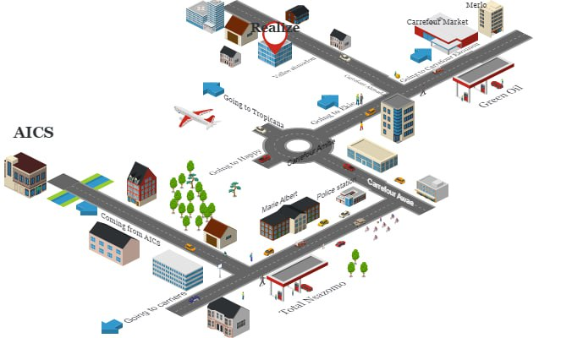

Figure 1: Geolocation of REALIZE Cameroon

- ORGANIZATION OF REALIZE
Understanding how each department within an enterprise works and what they contribute to its success can help expand both enterprise integration and knowledge. REALIZE is organised as follows:
- GENERAL MANAGEMENT
It is in charge of managing the day-to-day operations of the enterprise. It has as mission:
- To draft the comprehensive work plan, summary, and report documents;
- To comprehensively coordinate the daily administrative affairs management and the various departments of the enterprise;
- Managing the enterprise infrastructure;
- COMMUNICATION DEPARTMENT
They have as responsibilities:
- Multimedia communication and marketing;
- Management of cultural affairs;

- HR DEPARTMENT
This department is responsible for:
- They are in charge of managing employees according to the employee attendance policy;
- Recruitments;
- SOFTWARE ENGINEERING DEPARTMENT
This is the department to which all the interns were assigned. This department is in charge of the following:
- Conception and Realization of programming services;
- Evaluation and Realization of projects;
- DEPARTMENT OF FINANCIAL AFFAIRS
This department is in charge of Financial Accounting and Taxation.
- CERTIFICATION AND TRAINING DEPARTMENT
This department is in charge of:
- Managing the different Training programs and projects;
- Training and issuing certificates after training;
- TECHNICAL DEPARTMENT
This department is in charge of: Innovation, Maintenance, Telecommunication and Networking.
GENERAL MANAGEMENT
Communication Department
Human Resource Department
Financial Affairs Department
Certification and Training Department
Software Department
Technical Department

Figure 2:Organisation Chart of REALIZE Cameroon

- HARDWARE AND SOFTWARE RESOURCES OF REALIZE
- HARDWARE RESOURCES
Table 1: Hardware Resources of REALIZE
$$N^{O}$$ | Designation | Quantity | Characteristics | Observation
1 | MacBook Pro | 1 | APPLE | Good
2 | Modem | 1 | CAMTEL | Good
3 | LCD Screen | 1 | HP | Excellent
4 | Training equipment and office furniture | / | / | /

- SOFTWARE RESOURCES
Table 2: Software Resources of REALIZE

Designation | Software
Operating system | Windows 10, Mac OS, parrot Linux
Design tools | Photoshop
Integrated Development Environment (IDE) | Visual studio code,
Text Editor | Sublime text, notepad++
Database Management System (DBMS) | MongoDB, PostgreSQL, MySQL
Web browser | Google Chrome, Microsoft Edge
Document editor | Microsoft office word
Presentation | Microsoft Office PowerPoint

- BRIEF PRESENTATION OF PROJECT
Cameroon’s cooking gas market has recently undergone a significant transformation at least seven (7) brands of domestic gas are now available, each vying for market share through persuasive ads in newspapers, on radio and TV, and billboards. Despite these changes, the market still faces several challenges, particularly affecting domestic vendors and clients. To address these challenges, we propose a project titled: "DEVELOPMENT OF A WEB-BASED APPLICATION FOR GAS BOTTLE PURCHASE SUPPLY AND DELIVERY IN CAMEROON (CASE STUDY: YAOUNDE)." This project aims to develop a Web-based Application. It aims to automate, streamline, and monitor the gas distribution process, ensuring robustness, security, efficiency, and integrity in the gas market sector, especially benefiting buyers and vendors of domestic gas.

CONCLUSION
In general, insertion plays a vital role in the internship life cycle of a student as it possesses the student with a spirit of collaboration. To us, it was fabulous, enthusiastic, and fluid with countless workers including our professional supervisor. Next, we have the Existing System.

Preamble
PART 2: TECHNICAL PHASE

During the Insertion Phase, our objective was to familiarize ourselves with the reception structure. This phase focuses on the various characteristics, specificities, and expectations of the subject under our study.

Content:

INTRODUCTION
I.
EXISTING SYSTEM
II.
SPECIFICATION BOOK
III.
ANALYSIS PHASE

IV.
CONCEPTION PHASE
V.
REALIZATION PHASE
VI.
FUNCTIONALITY TESTING
VII.
REALIZATION PHASE
CONCLUSION


CHAPTER 1: EXISTING SYSTEM

Preamble

This document involves gathering information about the current system, including its purpose, functions, processes, and data. The goal of this document is to identify the strengths and weaknesses of the existing system in order to design a new system that betters meets the needs of the users or the organization



PROBLEMATIC
LIMITATIONS OF EXISTING SYSTEM AND

Content:
INTRODUCTION

PRESENTATION OF THEME
CONCLUSION
PROBLEMATIC
CRITICISMS OF THE EXISTING

STUDY OF THE EXISTING SYSTEM

INTRODUCTION
We initiate our exploration by delving deep into the existing system. This serves a dual purpose: recognizing its merits and equally importantly, identifying areas where it falls short. By casting a critical eye, we don’t just identify problems; we open doors to potential improvements and innovative solutions. This section will articulate challenges, discrepancies, and the gaps we aim to bridge.

- PRESENTATION THEME
Community event management in Cameroon, particularly within religious and social groups, is evolving rapidly. Despite this progress, challenges persist in organizing, coordinating, and managing events effectively, especially when relying on traditional methods. To address these challenges, we propose a project with the following theme:
THEME:
DEVELOPMENT OF A WEB-BASED COMMUNITY EVENT MANAGEMENT SYSTEM CASE STUDY: APOSTOLIC CHURCH PASTOR CHILDREN COMMUNITY CAMEROON

DEFINITION OF TERMS:
- Web-based Application: A software application that runs on a web server and is accessed through a web browser over the internet or an intranet.
- Communication: The process of sharing information about events with members, including announcements, updates, and reminders through the web-based platform.
- Event Creation: The process of planning and setting up an event, including specifying details such as date, time, venue, and type of event.
- Participation: The act of attending or engaging in an event. Here, it includes both physical attendance and virtual participation in hybrid events.

- STUDY OF THE EXISTING SYSTEM
- DELIMITATION OF THE FIELD OF STUDY
Our field of study is focused on the existing processes involved in the planning, organization, and management of community events within the Apostolic Church Pastor Children Community Cameroon. It examines the traditional methods of announcing and coordinating events, such as verbal communication, physical notices, and informal messaging, as well as the interactions between organizers, participants, and other actors. These manual approaches face challenges such as poor information dissemination, scheduling conflicts, limited participation, and the inability to reach members who cannot be physically present.
Based on the analysis of this context, our primary aim is to automate the process of event creation, communication, and participation by developing a web-based application accessible to all actors (organizers, participants, and administrators) on any platform with a browser and internet connection. In addition, the system is designed to support hybrid events, making it possible for members to attend either physically or virtually, thereby expanding inclusiveness and accessibility within the Apostolic Church Pastor Children Community Cameroon

- DESCRIPTION OF THE EXISTING SYSTEM
We observed that the current system for organizing community events within the Apostolic Church Pastor Children Community Cameroon relies heavily on manual methods of coordination, communication, and participation. Below is an illustration of how event planning and participation currently operate:
- Most events are organized only when organizers decide on a date, often without prior consultation with members.
- Event announcements are made verbally, via phone calls, or informal messages, and participants often rely on word-of-mouth to learn about events.
- Members must usually attend physically, limiting participation for those unable to travel.
- Event registration, resource allocation, and attendance tracking are managed manually, leading to errors, delays, and coordination difficulties.
- Communication during events, such as reminders or schedule changes, is inconsistent and may not reach all members.
These manual practices result in low engagement, poor information dissemination, scheduling conflicts, and a lack of inclusiveness for members who cannot attend in person. The system also lacks a unified method to track participation, collect feedback, and manage event logistics efficiently.

- CRITICISMS OF THE EXISTING
At the end of our information gathering, analysis of the current system for organizing community events within the Apostolic Church Pastor Children Community Cameroon reveals several critical issues. These criticisms include:
- Event Communication: Event announcements rely on verbal messages, bulletin boards, or word-of-mouth, leading to missed updates and little or no real-time communication with attendees.
- Event Management & Scheduling Errors: Event details such as venue, time, and logistics are tracked manually. This leads to overlaps, double bookings, and scheduling conflicts, especially when multiple organizers are involved
- Limited Visibility: Different zone managers often do not have up-to-date information on other events, making conflicts apparent only at the last minute and causing cancellations or rescheduling.
- Event Discovery & Awareness: Members, particularly new or occasional attendees, may not know about upcoming events due to lack of a centralized platform for event listings.
- PROBLEMATIC
“How can we improve the planning, management, and communication of community events to ensure efficient organization, clear communication, hybrid participation, and increased engagement?’’

- LIMITATIONS OF EXISTING SYSTEM AND PROPOSED SOLUTIONS
In this section, we will explore the limitations(problems) in detail and propose solutions that can be implemented to address these challenges.
Table 3: Limitations of the existing system and proposed solutions
Problem | Consequences | Proposed Solution(s)
Event announcements rely on word-of-mouth or chat groups | Missed updates, low participation, confusion among members | Develop a web-based platform that centralizes event announcements and sends real-time notifications via SMS, email, or app alerts
Events managed manually with notes or spreadsheets. | Human errors, scheduling conflicts, missing information | Implement a digital system for structured event creation, scheduling, and resource management
No centralized event listing or discovery | Members cannot plan ahead, lower attendance | Implement an online event listing with clear, searchable schedules accessible to all members
No real-time streamin during events | Client wastes time and energy since they have to transport the gas bottle themselves.  Increased transport costs due to varying prices for delivery. | Develop a Web application that will connect clients with a network of vetted delivery personnel, providing reliable and timely delivery services for gas bottles.

CONCLUSION
Studying the existing system is crucial for several reasons. It allows analysts to understand the current processes, workflows, and functionalities in place. In this section, we describe the existing system, highlight its weaknesses and challenges, and propose a solution. With this foundation, we proceed to the specification book.



CHAPTER 2: SPECIFICATION BOOK

Preamble

This document frames the student’s academic internship and is designed collaboratively by the project owner and project manager. This stage involves organization, planning, adherence to pedagogical standards, and work monitoring. It serves as a vital reference point throughout the project, helping to manage expectations, control costs, and maintain quality.



Content:
INTRODUCTION
I.
CONTEXT AND JUSTIFICATION OF PROJECT
CONCLUSION
VII.
V.
IV.
DELIVERABLES
PROJECT CONSTRAINTS
ESTIMATED COST OF PROJECT
PROJECT PLANNING
EXPRESSIONS OF NEEDS
III.
II.
PROJECT OBJECTIVES
VI.
INTRODUCTION
Embarking on a project without a detailed specification book can lead to numerous pitfalls. Detailed specifications are essential for avoiding these issues, ensuring that the project is completed on time, within budget, and to the highest quality standards. This document permits us to provide detailed, precise description of the requirements(clients), deliverables (products), and resources (workmanship) required to complete this project.

- CONTEXT AND JUSTIFICATION
- CONTEXT
Over the years, community event coordination within the PC’S TACC Community Cameroon has faced significant challenges, particularly in organizing, announcing, and managing events efficiently. Currently, events are often communicated through word-of-mouth, chat groups, or informal methods, which leads to missed information, low participation, and scheduling conflicts. Event management is mostly manual, relying on paper notes, spreadsheets, or basic messaging tools, making it difficult to track details, coordinate volunteers, and ensure smooth operations.
To address these issues, we propose a web-based community event management system that enables organizers to create, manage, and communicate events digitally. The system will support hybrid participation (both physical and virtual), provide real-time updates, and centralize event information, allowing members to stay informed, RSVP, and participate effectively.

- JUSTIFICATIONS
The existing challenges in event coordination highlight the need for a centralized, digital solution to improve communication, scheduling, and participation. Our proposed project, “Development of a Web-Based Community Event Management System (Case Study: PC’S TACC Community Cameroon)”, aims to:
- Centralize event creation and management for organizers;
- Enable members to discover events and plan attendance in advance;
- Provide real-time notifications and live updates during events;
- Facilitate hybrid participation for both physical and virtual attendees;
- Enhance overall engagement, efficiency, and user experience within the community.

- PROJECT OBJECTIVES
- GENERAL OBJECTIVE
Develop a web-based community event management system that enables organizers to create, manage, and communicate events efficiently, while allowing members to participate physically or virtually, improving engagement, coordination, and accessibility.
- SPECIFIC OBJECTIVES
With this platform:
- Members:
- View upcoming events and access detailed event information.
- Remotely Join an Event Live Stream.
- Remotely make a contribution
- General manager and Zone Event managers should be able to:
- Manage events efficiently, including creation, updates, and cancellations.
- Manage event categories to ensure proper organization.
- Zone Event Managers should be able to submit events for validation by the General Event Manager.
- The General Event Manager should be able to review and publish approved events submitted by Zone Event Managers.
- Admin should be able to:
- Manage user accounts, including creating, updating, and deactivating accounts.
- Manage zones, including adding, updating, or removing zones as needed.
The project has the following characteristics:
- Name of Project: PC COMMUNITY EVENTS.
- Project Target: Efficient planning, management, and participation in community events
- Technical Specification: Web-based application supporting hybrid events.

- EXPRESSION OF NEEDS
- FUNCTIONAL NEEDS
These are the requirements that the system must meet to fulfil its purpose, typically expressed in terms of the system’s inputs, outputs, and behaviours. They are as follows:
- The administrator should be able to:
- View Account
- Delete Account
- Assign User Roles
- Block Account

- Manage Member Account
- Add Member Account
- View Account
- Delete Account
- Block Account
- Manage Zone Event Manager Account
- Add Zone Event Manager Account
- View Account
- Delete Account
- Block Account
- Manage General Event Manager Account
- Add Account

- The Zone Event Manager should be able to:
- Create Account
- Authenticate
- Create Event
- Submit Events for validation by the General Event Manager
- Update Events within assigned zone
- Cancel Events within their assigned zone
- Stream Event
- View Contributions within assigned zone
- The General Event Manager should be able to:
- Stream Event

- Create Account
- Create Global Events
- Update Global Events
- Validate and Publish Zone Events
- Manage Event Categories

- The Client should be able to:
- Create Account
- Login
- View Upcoming Events (Zone, Global)
- Receive real-time notifications and updates
- Join Live Stream
- Create Post
- View Posts
- Make Contributions

- NON-FUNCTIONAL NEEDS
These specify the quality attributes of a software system. They evaluate the software system based on its performance, usability, scalability, portability, and other non-functional standards that are critical to its success. Failing to meet these non-functional needs can result in the system not fulfilling the users' needs.
    - Performance and Scalability:
Performance refers to how quickly the web application responds to user actions under various workloads. It measures how long a user must wait for the system to process an action, such as placing an order, even when multiple users are using the application simultaneously. In addition, performance includes background operations that ensure smooth functioning without user awareness. Our goal is to deliver optimal performance, as it greatly impacts user satisfaction and overall experience.
Scalability, on the other hand, refers to the system’s ability to maintain its performance standards as the number of users increases. The platform should scale efficiently, ensuring clients, suppliers, and delivery personnel can all access it comfortably, even during peak demand.
    - Accessibility: The platform should be accessible across multiple platforms, including mobile phones, tablets, and desktop computers. As long as a user has a browser and an internet connection, the system should work seamlessly, ensuring flexibility in use.
- The application should be intuitive, with a simple user interface that allows users to easily navigate and complete tasks;
- The application should implement robust security measures to protect user data, ensuring safe transactions and preventing unauthorized access;
- The code should be clean and well-organized to allow for easy updates and future improvements.

- PROJECT PLANNING
Project planning involves scheduling tasks and milestones within a set time frame, based on the structured phases of the project. Our internship spanned three months, from the 3rd of July to the 30th of September, and the following outlines how the work phases were organized during this period.
- PROJECT PLAN
Table 4:Project Plan
TASK | Duration(days) | Period
Create an Insertion Document | 14 days | 03rd July - 18th July
Prepare an Existing System | 5 days | 19th July – 25th July
Production of Revised Specification Book | 5 days | 26th July - 1st August
Solution Analysis and Drafting of the Analysis Document | 14 days | 2nd August – 17th August
Conception | 14 days | 18th August – 2nd September
Realization | 14 days | 3rd September – 18th September
Functionality Test | 4 days | 19th September – 24th September
Writing User Guide | 3 days | 25th September – 29th September

- GANTT DIAGRAM
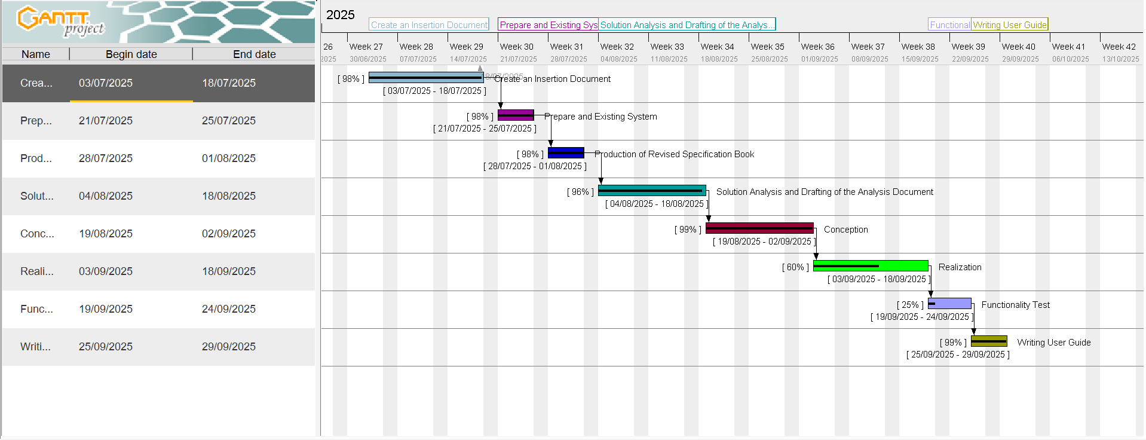
The Gantt chart is a project management tool that provides a visual representation of a project's schedule. It displays the various tasks and their timelines, allowing project managers to track progress and ensure timely completion. The Gantt chart for this project is as follows:

Figure 3: Project plan

- ESTIMATED COST OF PROJECT
Project cost estimation involves calculating the total expenses, including human resources, hardware, and software of the project. It is critical for any project and essential for effective project management. The tables below provide a detailed breakdown of the project cost estimation.
- SOFTWARE RESOURCES
The following software applications or resources were necessary for the successful realization of this project:
Table 5: Software Resources (source: mercurial 2024)
Software Resource | Description | Quantity | Price (FCFA)/ day | Total Price  (FCFA)
Microsoft 365 | Suite for document creation, spreadsheets, presentations, and collaboration. | 1 | 47, 998 | 47, 998
Visual Studio | Integrated Development Environment (IDE) for coding and debugging. | 1 | Freeware | Freeware
Node.js | JavaScript runtime environment for building server-side applications. | 1 | Freeware | Freeware
MySQL Workbench Community Edition | Database design and management tool for MySQL. | 1 | Open Source | Open Source
XAMPP | Local server for testing and running PHP and MySQL applications. | 1 | Open Source | Open Source
Git | Version control system used to track changes in the project code. | 1 | Open Source | Open Source
GitHub | Online platform for hosting and managing code repositories. | 1 | Freemium | Freemium
Thunder Client | API testing tool integrated with Visual Studio Code. | 1 | Freeware | Freeware
Mozilla Firefox | Web browser used for testing and development. | 1 | Freeware | Freeware
Visual Paradigm | creating UML diagrams and system modelling. | 1 | Freemium | Freemium
Icogram | Software for designing illustrative diagrams and graphics. | 1 | Freemium | Freemium
GanttProject | Project management tool for creating Gantt charts | 1 | Freeware | Freeware
Total Cost of Software Resources (FCFA) |  |  |  | 47, 998

- HARDWARE RESOURCES
This includes the material resources used to realise the project. The table below provides a summary of these materials.
Table 6: Hardware Resources (source: mercurial 2024)
Hardware Resource | Quantity | Price (FCFA) / day | Total Price (FCFA)
Laptop Acer Spin 3  10th Gen Intel Core i5-1035G1 14,  8 GB RAM, 256 GB SSD | 01 | 287,359.25 | 287,359
Modem (Camtel) | 01 | 40,000 | 40,000
Internet Connection | / | 20,990 | 20,990
Total Cost of Hardware Resources (FCFA) |  |  | 348,349

- HUMAN RESOURCES
Table 7: Human Resources
Human  resource | Quantity | Price (FCFA)/ day | Duration (days) | Total Price (FCFA)
Project Manager | 01 | 40,500 | 90 | 2,745,000
Analyst | 01 | 35,000 | 21 | 735,000
UI/UX Designer | 01 | 30,000 | 10 | 300,000
Developer | 02 | 80,000 | 30 | 2,400,000
Tester | 01 | 20,000 | 14 | 280,000
Total Cost of Human Resources (FCFA) |  |  |  | 6,460,000

TOTAL ESTIMATED COST FOR THE PROJECT
Table 8: Total Estimated Cost for Project
SOFTWARE RESOURCE | 47, 998 FCFA
HARDWARE RESOURCE | 348,349 FCFA
HUMAN RESOURCE | 6,460,000 FCFA
Unexpected charges (10%)  (Total cost) * 10% | 680,939.4 FCFA
TOTAL COST | 7,490,333.4 FCFA
Total | 7,490,333.4 FCFA
SUM TOTAL:
7, 490, 333.4 FCFA
Seven Million, Four Hundred and Ninety Thousand Three Hundred and Thirty-Three Point Four FCFA

- PARTICIPANTS
The table below presents the different individuals who took part in the accomplishment of this project. They include:
Table 9 : Project Participants
Names | Functions | Role and Tasks
Mr. | Full Stack Developer at Realize | Professional Supervisor
Mr. BILL NELSON | Lecturer at AICS-Cameroon  Software Engineer | Academic Supervisor
Mr. BALEMBA JESSE NJEA MASSOMA | Second year Student at AICS - Cameroon | Project Head, Analyst, Project Design and Coding, Testing.

- PROJECT CONSTRAINTS
Because every project and its resources are finite, we must respect three main constraints which includes;
- Budget Constraint: The total budget for the project is strictly limited to 7,490,333.4 FCFA and must be adhered to without exceeding this amount;
- Deadline Constraint: The project must be completed within a duration of 3 months, starting from July 3rd, 2024, while meeting all specified objectives and milestones;
- Quality Constraint: The application must be flexible, web-based, and reusable, ensuring it meets high standards of user-friendliness, reliability, and security.
- DELIVERABLES
In this section, we will outline the elements to be delivered upon project completion. These include:
- A CD-ROM containing the web application;
- The installation guide and user manual;
- A PowerPoint presentation of the application;
- A video demonstration of the application's functionality.

CONCLUSION
Creating a specification book is a necessary step in minimizing the risks of a project. On the one hand, it serves to fulfil the requirements listed in the specifications and to plan the implementation in the best possible way so that there are no nasty surprises at the end. On the other hand, it helps to validate the implemented solution at the end of the project and to protect both parties. Through these we are now going forth to the Analysis.



CHAPTER 3: ANALYSIS

Preamble

The Analysis file provides a detailed explanation of the solution using diagrams. Its main purpose is to capture user’s needs and define the process and methodologies used to address those needs.



Content:
INTRODUCTION
I.
METHODOLOGY
CONCLUSION
d.)
c.)
b.)
a.)
ACTIVITY DIAGRAM
SEQUENCE DIAGRAM
b.)
a.)
II.
COMMUNICATION DIAGRAM
USE CASE DIAGRAM
MODELLING
COMPARATIVE STUDY OF UNIFIED PROCESSES
UML
COMPARATIVE STUDY BETWEEN MERISE AND
INTRODUCTION
The analysis phase of a project is a crucial step in ensuring that the solution aligns with the needs of the users. In this phase, we delve deeper into the proposed solution, providing a comprehensive explanation supported by diagrams. This document serves to clearly capture the user’s requirements while outlining the processes and methodologies that will be used to meet those needs. By offering a detailed analysis, we ensure that the project is built on a strong foundation, minimizing the risk of misunderstandings and ensuring a more successful implementation.

- METHODOLOGY
Analysis is a fundamental step in the conception of software and serves as the foundation for the realization of any information system. An information system involves the organization of resources; human, software, and hardware along with data and feedback mechanisms, to achieve a specific objective. Several methods and languages, such as UML and MERISE, have been developed to facilitate the analysis and design of information systems.
MERISE (Méthode d’Etude et de Realization Informatique pour les Systèmes d’Entreprise) it is a method of analysis, conception and realization of information systems mostly used in French Speaking Companies or Enterprises. It is based on the separation of data and processing them using several conceptual and physical models. Its principal objective is to conceive an information system. Merise proposes examining the real system from two perspectives:
- The Static View (data);
- The Dynamic View (treatments).
UML (Unified Modelling System) a standardized modelling language consisting of an integrated set of diagrams, developed to help system and software developers for specifying, visualizing, constructing, and documenting the artifacts of software systems, as well as for business modelling and other non-software systems. UML proposes an approach different from MERISE as its readability and reusability makes it an ideal choice for programmers.

UML is currently at it 2.5 version and presents a number of advantages which includes:
- It is a formal and standardize language.
- It provides visual representation of the structure and behaviour of the system which can help to communicate and understand the design of the system.
- It is flexible and customizable to suit different domain and technologies.
- It is readable and re-useable i.e. you can easily see the relationships and interactions between classes and objects in UML.

UML is divided into two categories of diagrams:
- Structural diagrams, which illustrate the building blocks of the system, and
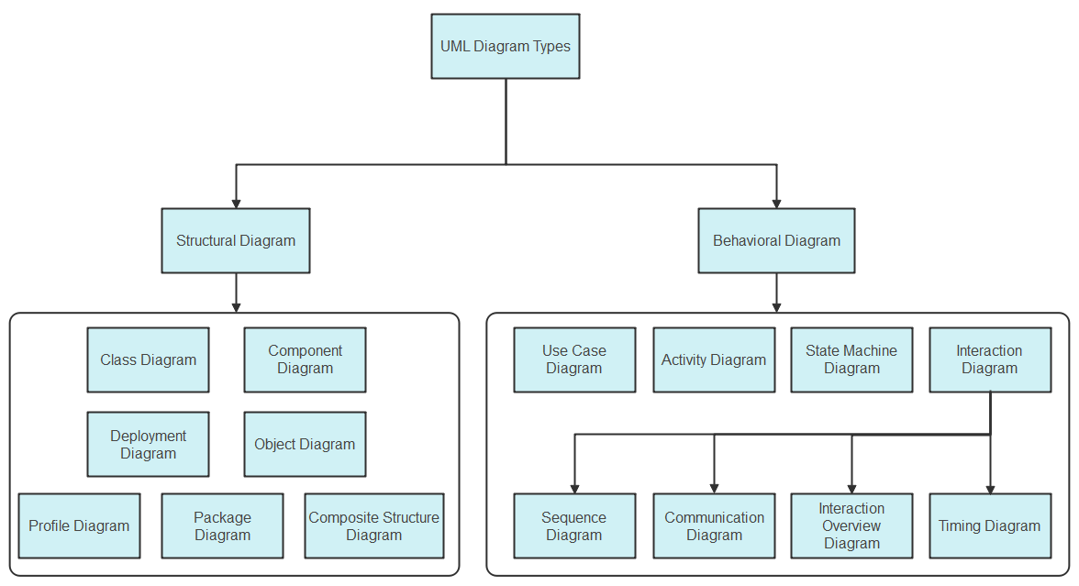
- Behavioural diagrams, which demonstrate how the system responds to changes, as shown below.
Figure 4: UML hierarchy diagram (source: https://images.edrawsoft.com/articles/what-is-uml/uml-diagram-types.png)

- COMPARATIVE STUDY BETWEEN MERISE AND UML
Table 10: Comparative Study between UML and MERISE
MERISE | UML
MERISE stands for Méthode d'Étude et de  Réalisation Informatique pour les Systèmes  d'Entreprises. | UML stands for Unified Modelling Language.
MERISE is a method for designing processing- and data-oriented systems. | UML is a modelling language, not a method. It needs a method that uses the UML language to design the system. (e.g. UP, RUP, 2TUP and possibly agile methods).
Less widely used | Widely used
Less complex and little or no time-consuming. | Complex and time-consuming due to the many diagrams it has.
Design for Organizational Information Systems. | Designed for Object-Oriented-based Information Systems.

- COMPARATIVE STUDY OF UNIFIED PROCESSES
- PRESENTATION OF UP METHOD
UP (Unified Process) is an iterative, incremental, architecture-centric, and use-case-driven approach to software development built on UML. UP is organised into four major phases:
      - Inception: Defines project foundation, business case, scope, and boundaries.
      - Elaboration: Captures system requirements and plans risk management.
      - Construction: Builds the final product iteratively, focusing on lower-risk elements.
      - Deployment: Delivers the system to users, including data migration and training.
Each phase and its iteration consist of a set of predefined activities also known as disciplines. These disciplines include: Business modelling, Requirements, Analysis and Design, Implementation, Test and Deployment.

The different phases of the Unified Process (UP) are shown below:
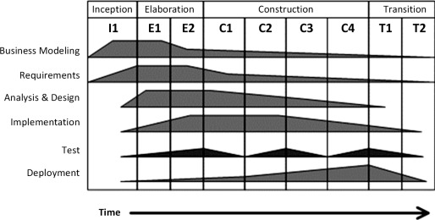

Figure 5: Phases of UP (source: https://ars.els-cdn.com/content/image/3-s2.0-B9780128054765000022-f02-01-9780128054765.jpg )

- PRESENTATION OF THE 2-TUP METHOD
2TUP is a software development process that implements the unified process (i.e. iterative, incremental, based on UML). It proposes a development cycle which separates the technical aspects from the functional aspects. It begins with a preliminary study which essentially consists of identifying the actors and the system exchange. Then to produce the specifications and to model the context.
The software development process is structured around three branches:
- Functional branch (the left-hand branch of the Y): identifies and models the users' business needs.
- Technical branch (the right-hand branch of the Y): lists the technical needs and proposes a generic design validated by a prototype.
- Realization branch (the middle branch): combines both functional and technical branches, enabling application design and ultimately delivering a solution tailored to the needs. This branch includes:
- Preliminary design: integrates the analysis model into the technical architecture to map out the system's components;
- Detailed design: studies how to make each component;
- Coding stage: produces the components and progressively tests the code units produced;
- Acceptance(recipe) stage: consists in validating the functions of the developed system.

Below is a graphical representation of the Two Track Unified Process (2TUP)

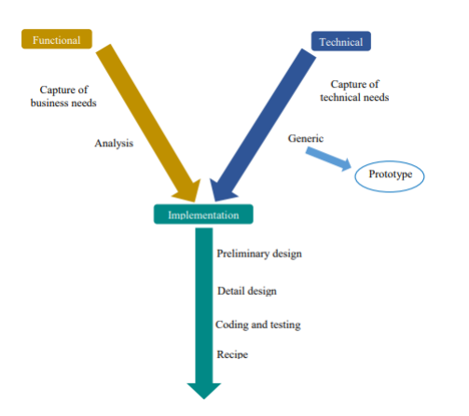

Figure 6: Graphical representation of 2TUP (source: Mr. Messio UML course AICS-Cameroon 2023-2024)

- COMPARATIVE STUDY BETWEEN 2TUP AND UP
Table 11: Comparative study between 2TUP and UP
2TUP | UP
2TUP is a software development process that implements the unified process (i.e. iterative, incremental, based on UML). | The Unified Process is a generic name for a family of process models that meet a number of criteria, such as being iterative and incremental, driven by use cases, and focusing on addressing risks early. It defines four project phases: Inception, Elaboration, Construction, and Transition.

- JUSTIFICATION ON THE CHOICE ANALYSIS
Our choice was based on the UML modelling language, combined with the 2TUP analysis method, due to the following criteria:
- UML is based on object-oriented approach;
- UML modelling also supports multiple views of the same system.
- UML enables the creation of specialized diagrams by focusing on specific elements for a particular purpose at a given time.
- 2TUP is a software development process built on the UML modelling language.
- 2TUP is user-oriented because built on their expectations (i.e. permits the development of software that responds to users' needs).

- MODELLING
- USE CASE DIAGRAM
- Definition
A Use case diagram captures a system's high-level functions(requirements), dynamic nature and scope.
Use Case diagram serve for the following purposes;
- Specify the context or scope of a system.
- Capture the requirements of a system.
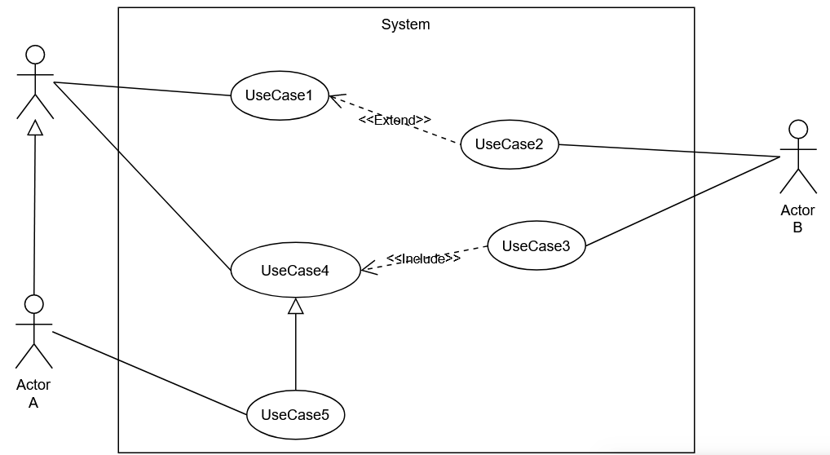
- Formalism

Figure 7: Use Case Diagram Formalism

ELEMENT | DESCRIPTION | NOTATION
Actor | Any Entity external to a system interacts with the system, maybe a human user or another system, and has goals and responsibilities to satisfy  in interacting with the system. | 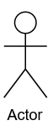
Use Case | A use case corresponds to a system's objective motivated by the actors' needs. | 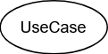
Association | It expresses the interaction between an actor and a use case.
Include | An Include Association from one use case (called the Base use case) to another use case (called the inclusion use case) indicates that the base use case will include or call the inclusion use case.
Extend | An Extend Association indicates that the extension use case will extend into) and augment the Base use case.
- Components of a Use Case Diagram
Table 12: Components of a Use Case Diagram

Table 13: Components of Use Case Diagram (Continued)
ELEMENT | DESCRIPTION | NOTATION
Generalisation  (Actor) | An Aactor generalization from a specialized, actor to a generalized, actor indicates that instances of the more specific actor may be substituted for instances of the more general actor. | 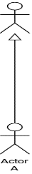
Generalisation  (Use Case) | A use case generalization indicates that a specific use case inherits the behavior and characteristics of a more general use case. | 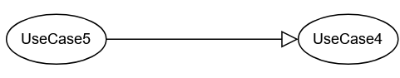
System | It identifies what is part of the system and the actors interacting with it. | 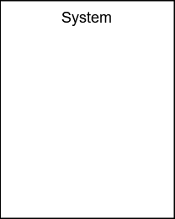

- General Use Case Diagram
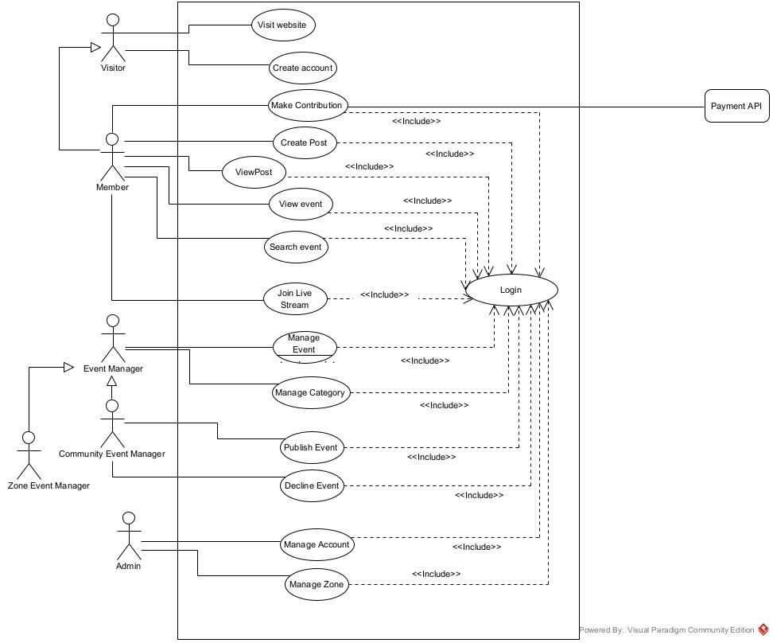

Figure 8: General Use Case Diagram

- Manage Event Specific Use Case Diagram
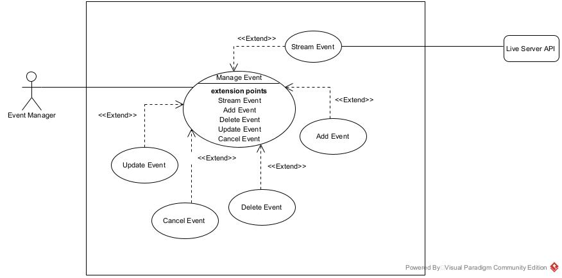

Figure 9: Manage Event Specific Use Case diagram
- Join Live Stream Specific Use Case Diagram
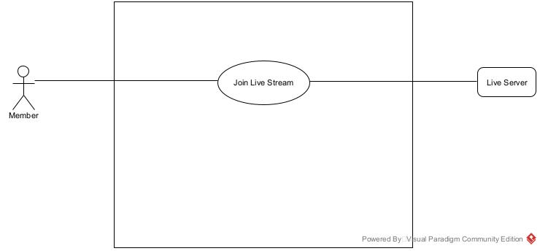
Figure 10: Join Live Stream Event Specific Use Case Diagram

- Create Post Specific Use Case Diagram
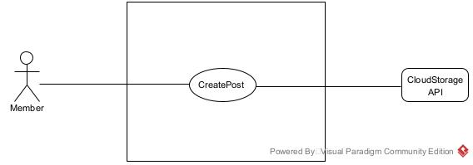
Figure 11: Create Post Specific Use Case Diagram

TEXTUAL DESCRIPTION OF USE CASES
Use Case can be considered as a behaviour that a system offers to the actors to help meet the actors’ goals. So, we have to supply information on how the use case works — and put that information somewhere in a Textual description (Specification). This set of needed details placed inside a use case is sometimes called the Use Case Textual Description.
Formalism
Table 14: Formalism of Textual Description of a Use Case
Title | Represents the name or title of the textual description
Description | It explains the goals, plot, and theme of the use case.
Actors | Description of the main and the secondary actors.
Date | Creation and update date.
Stakeholder | Names of creator(s).
Version | The version number.
Precondition | Specifies the state of the world that must be held before the course can be triggered.
Trigger | Any event that causes the use case to be initiated.
Nominal Scenario (Corresponds to the normal development of a use case)
Alternative Scenario (Corresponds to variants of the nominal scenario)
Post Condition of Success | Describes the state of the system after the end of each scenario.
Post Condition of Failure | Describes the state of the system after the end of each  Scenario.

- Textual Description of the Use Case <<Authenticate>>
Table 15: <<Authenticate>> Textual Description
Title | Textual description of a Use case << Authenticate >>
Description | This use case allows any Event Manager (Zone Event Manager, General Event Manager) with an existing account to log in to the system using their credentials.
Actors | Event Manager (Zone Event Manager, General Event Manager)
Date | September 11, 2025
Stakeholder | PC Community Directors
Version | 1.0
Precondition | The actor has an account in the system
Trigger | The actor clicks on the Login button
Nominal Scenario
- The use case starts when the actor clicks on the "Login" button.
- The system displays the login page.
- The system prompts for the actor’s credentials (Email and Password).
- The actor fills in the fields with their credentials.
- The system queries the actor’s (email-related) data from the database.
- The database sends the query results.
- The system verifies the actor’s credentials against the query results.
- The system displays the actor’s dashboard.
- The use case ends when the Event Manager gains access to the dashboard.
Alternative Scenario: Verification Failure
- At step 7 of the nominal scenario the system fails to verify the actor’s specified credentials.
- The system displays an error message indicating the issue.
- The use case continues at step 2 of the nominal scenario.
Post Condition of Success | The Event Manager gains access to Personal dashboard
Post Condition of Failure | Service provider unable to access dashboard
- Textual Description of the Use Case <<Create Event>>
Title | Textual description of the use case <<Create Event>>
Description | This use case allows the actor, Zone Event Manager to use a web browser to enter their address, select a merchant, specify a desired item, and obtain a confirmed order from the system.
Actor(s) | Zone Event Manager
Date | September 10, 2025
Stakeholder | PC Community Directors.
Version | 1.0
Precondition | Zone Event Manager Visits Dashboard wanting to create an Event
Trigger | Zone Event Manager clicks on “Create Event” button.
Nominal Scenario
- Zone Event Manager visit dashboard.
- The system displays Create Event Form
- The Zone Event Manager fill and submit form
- The system validates form
- The system send query to save event with status = ‘pending’.
- The database returns the result of the query
- The System display a successful message to the user (Zone Event Manager)
Alternative Scenarios:
- At step 4 of the nominal scenario, the form is invalid.
- The system displays an error message and continues from step 3 of the nominal scenario.
- At step 6 of the nominal scenario, the database returns an error after processing or treating the query and continues from step 3 of the nominal scenario
Post Condition of Success | The Zone Event Manager successfully creates an event.
Post Condition of Failure | The Zone Event Manager fails to create an event.
Table 16: <<Create Event>> Textual Description
- COMMUNICATION DIAGRAM
- Definition
A Communication diagram focuses on the messages between a group of objects and the underlying messages of the objects. They show how objects collaborate to meet a goal. In other words, they are time- and space-oriented and emphasize the overall interaction, the elements involved, and their relationships.
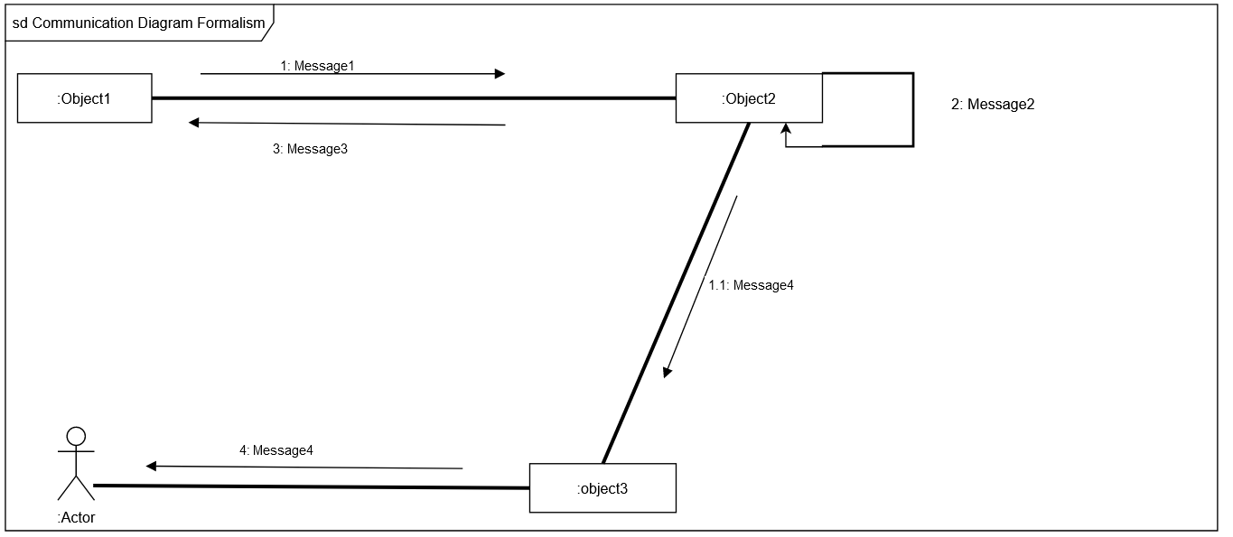
- Formalism

Figure 13: Communication Diagram Formalism

- Components of a Communication Diagram
Table 19: Components of Communication Diagram
ELEMENT | DESCRIPTION | NOTATION
Message | It defines the communication between two objects at a given instant. | 1messageA()[condition]
Link | a link is a tool in a UML diagram to indicate that two objects communicate with each other. | 
Object | Objects can be any useful item that has identity, structure, and  behaviour. | 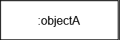
Actor | A role played by an entity. | 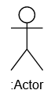

- <<Authenticate (Login)>> Communication diagram
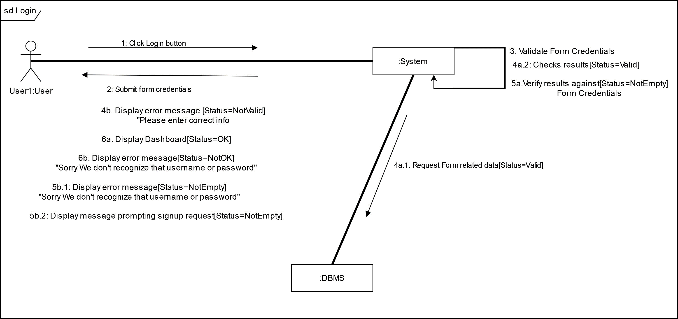
:Member

Figure 14: Communication Diagram for <<Authentication (Login)>>

- <<Create Event>> Communication diagram

Figure 15: Communication diagram for <<Create Event>>

- <<Create Category>> Communication diagram
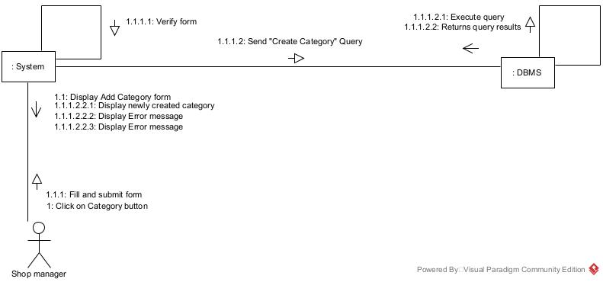
: Event Manager

Figure 16: Communication diagram for <<Create Category>>

- SEQUENCE DIAGRAM
- Definition
A sequence diagram is an Interaction diagram which captures the exchange of messages between participating objects. They are time-oriented and emphasize the overall flow of an interaction.
- Formalism
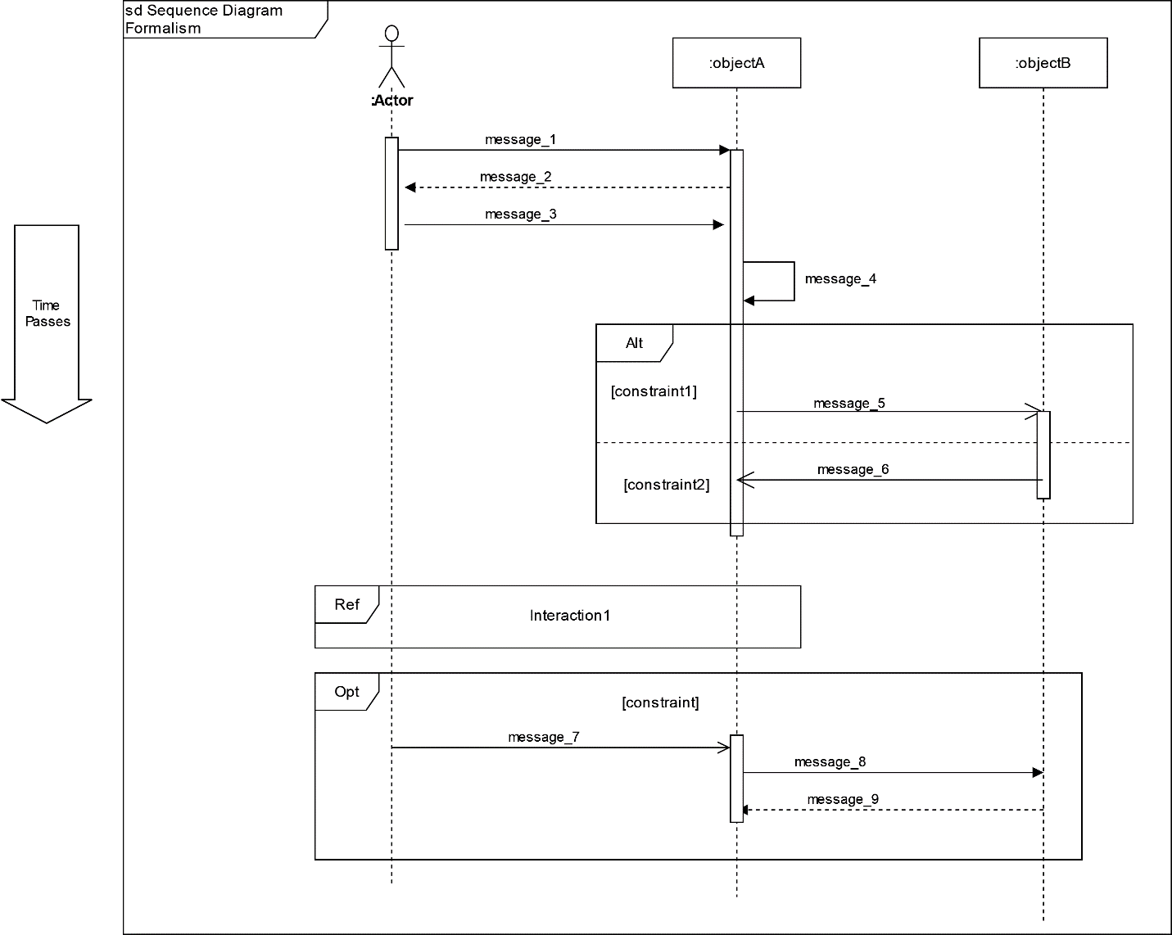

Figure 18: Sequence Diagram Formalism

- Components of a Sequence Diagram
Table 20: Components of a Sequence Diagram
ELEMENT | DESCRIPTION | NOTATION
Lifelines | It is a vertical dashed line from an element which represents the existence of the element over time.
Object | It’s an instant of a class. | 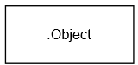
Actor | Communicate with other objects. | 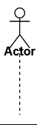
Activation | It represents the period during which an element is performing an operation.
Message | It indicates the communication between objects. We have Synchronous messages, reply messages, Asynchronous messages and Self messages as types of messages. | 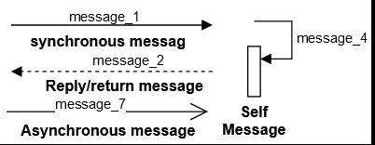

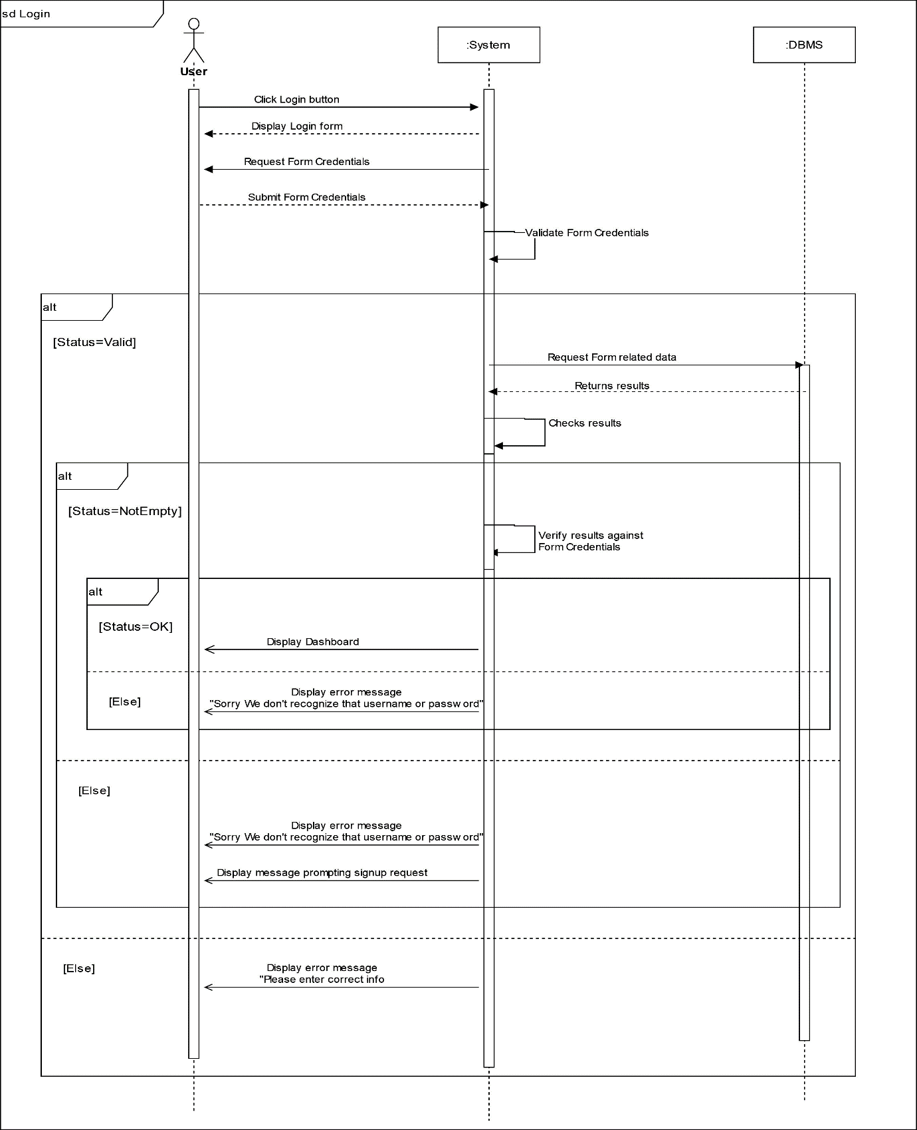
- <<Authentication (Login)>> Sequence Diagram
: Member

Figure 19: Sequence diagram for <<Authentication (Login)>>

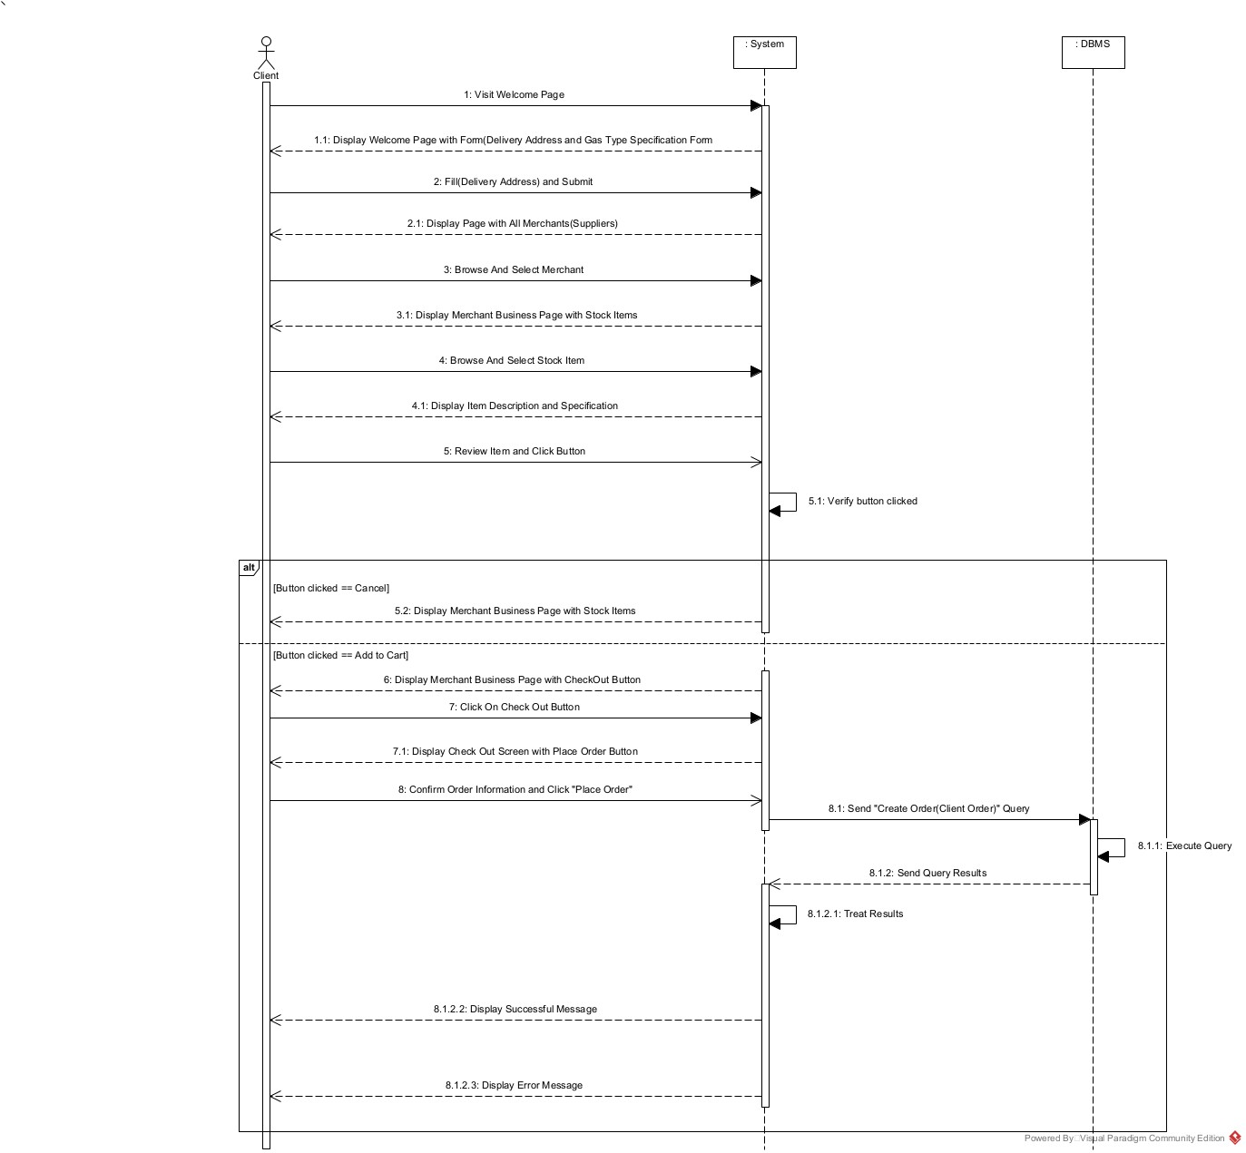
- <<Create Event >> Sequence Diagram

Figure 20: Sequence diagram for <<Create Event>>

- ACTIVITY DIAGRAM
- Definition
An activity diagram is a behavioural diagram that describes the sequence of actions in a process or specific activity, providing a view of the system's behaviour.
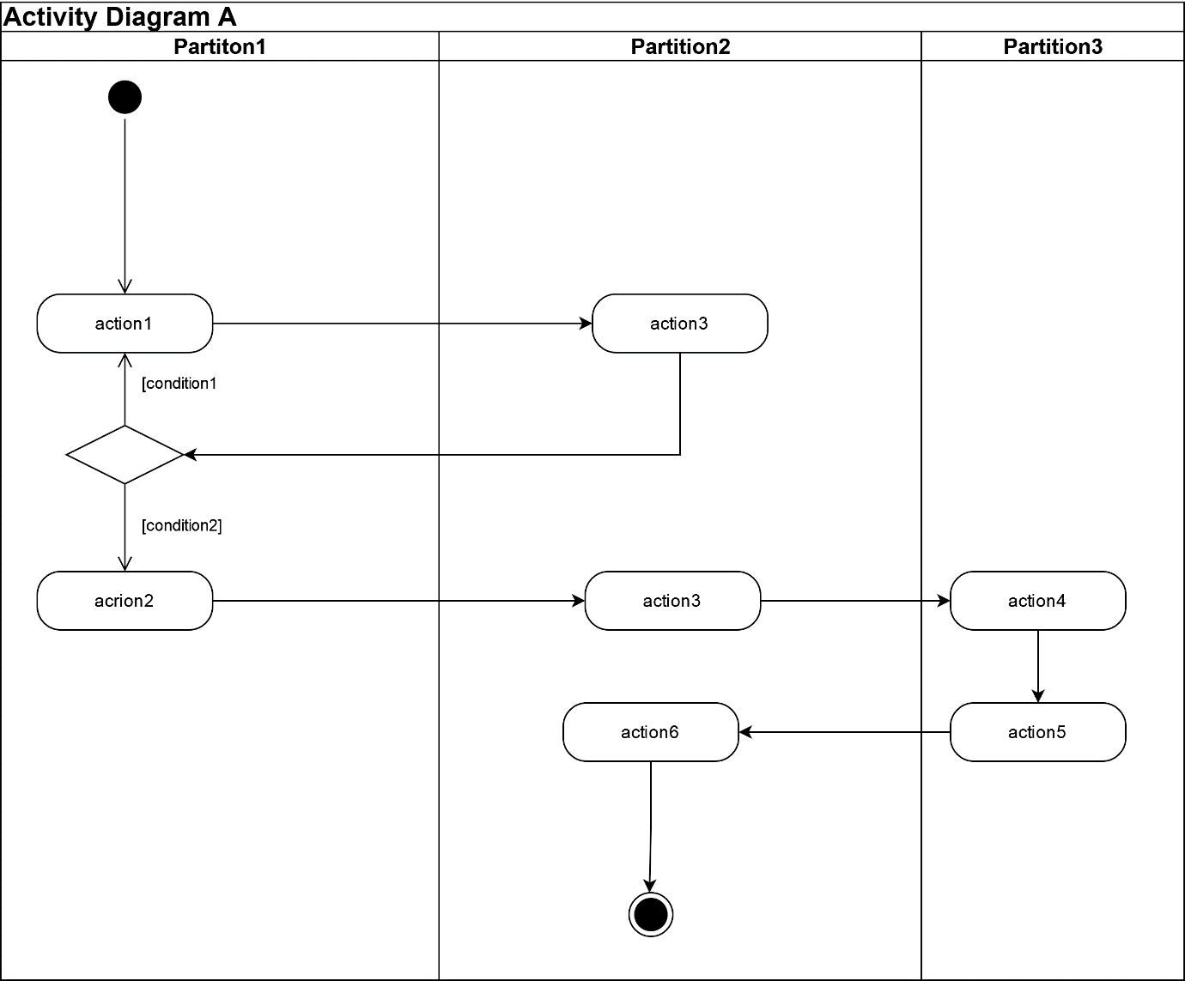
- Formalism

Figure 23: Activity diagram formalism

- Components of an Activity Diagram
Table 21: Components of an Activity Diagram
ELEMENTS | DESCRIPTION | NOTATION
Activity | Activities contain sequences of actions and/or other activities. You use activities to group sequences of actions together. | 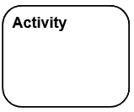
Action | An action is a simple piece of behaviour an action. | 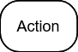
Object node | Represents an activity  node that indicates an instance of a particular classifier in the activity. | 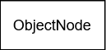
Control flow | Connects actions and activities together; shows the sequence of execution.
Initial node | This shows the starting  point or first activity of the flow. | 
Final activity node | Ends all control flows and object flows in an activity, using the final-activity node. | 
Final flow node | End some — but not all — flows inside an activity. | 
Decision node | A decision node uses a test to make sure that an object or control flow goes down only one path. | 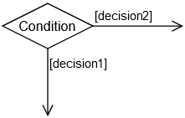
Merge | Brings separate decision paths back together. | 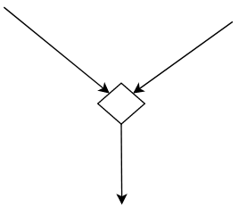
Fork node | Used to split behaviour into concurrent operations. | 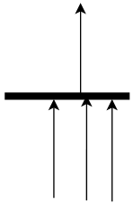
Join node | Used to synchronize incoming concurrent flows. | 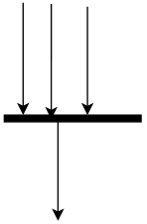
Swimlane | Swimlane is a visual region  in an activity diagram that indicates the element that has responsibility for action states within the region. | 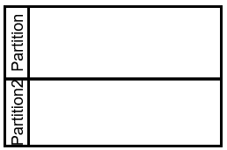

- <<Authentication>> Activity Diagram
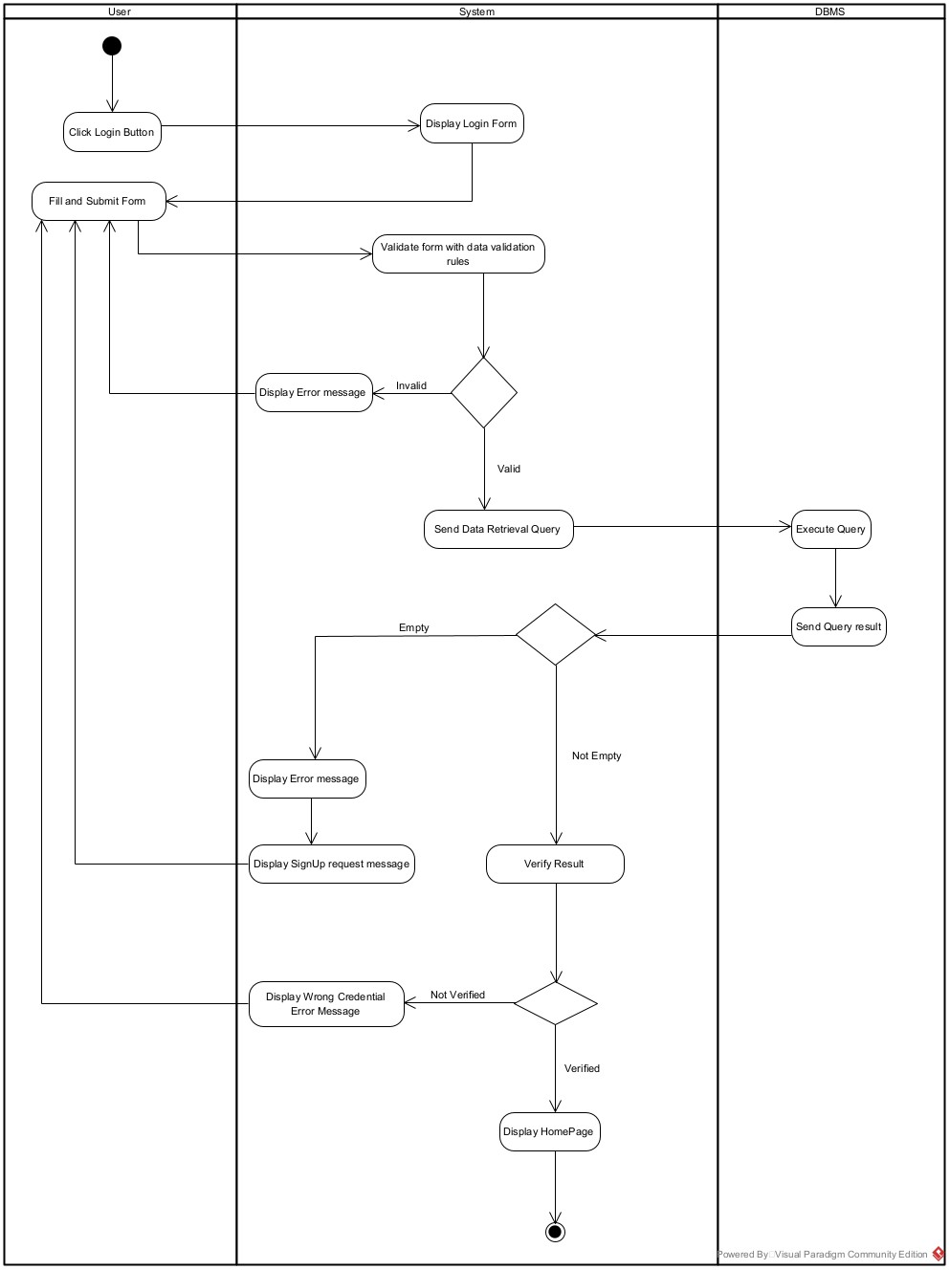
Figure 24: Activity diagram for <<Authentication>>

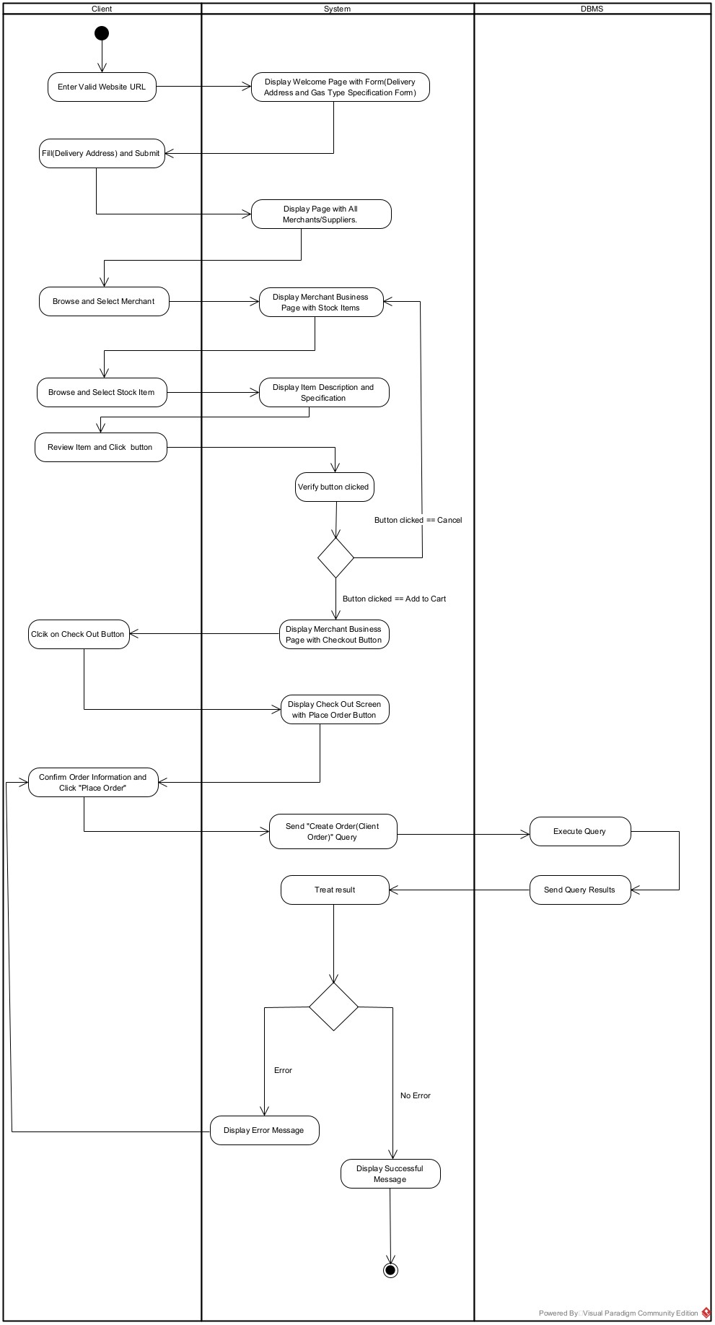
- <<Create Event>> Activity Diagram

Figure 25: Activity diagram for <<Create Event

CONCLUSION
Having completed our analysis, we were tasked with illustrating the language and method used during this phase and presenting the various diagrams of the functional branch. This analysis has allowed us to define the functional needs of the web application and provided a detailed overview of the new system to be implemented. Without wasting time, we quickly dive into the conception phase.



CHAPTER 4: CONCEPTION PHASE

Preamble

This document captures the technical requirements and establishes the system’s architecture, bridging the gap between the analysis and realization phases.



Content:
INTRODUCTION
I.
CLASS DIAGRAM
CONCLUSION
PACKAGE DIAGRAM
III.
II.
STATE MACHINE DIAGRAM
INTRODUCTION
The capture of the technical needs can be carried out as soon as the required resources are identified. These resources include machines, networks, components, etc. At this stage, we will examine diagrams such as class diagrams, package diagrams, state machine diagrams, and more.

- CAPTURE OF TECHNICAL NEEDS
- PHYSICAL ARCHITECTURE
Modern web application architecture typically consists of several layers that work together to provide a robust, scalable, and maintainable system. Each layer serves a specific purpose, and together they form a cohesive and integrated solution that can handle a variety of tasks.
Choosing the right architecture is a complex decision. While scalability, maintainability, and Data Integrity are essential considerations, other factors such as budget, time-to-market, and technology stack also come into play reason why we choose Three-tier architecture. Three-tier architecture is a well-established software application architecture that organizes applications into three logical and physical computing tiers. The three-tier architecture is the most popular implementation of a multi-tier architecture and consists;
- Presentation tier: The user interface where end-users interact with the application.
- Application tier: The logic layer that processes data from the presentation tier using business rules.
- Data tier: The database management system (DBMS).

Below is a visual representation of the Three-Tier Architecture.
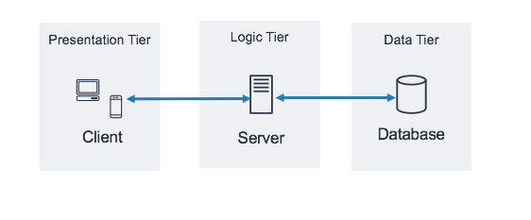

Figure 28: Visual representation of 3-Tier Architecture (Source: https://docs.aws.amazon.com/images/whitepapers/latest/serverless-multi-tier-architectures-api-gateway-lambda/images/image2.png )
- LOGICAL ARCHITECTURE
Model View controller or MVC as it is popularly called, is a software design pattern for developing application. A model view controller pattern is made up of the following three parts.
- Model: The lowest level of the pattern which is responsible for maintaining data.
- View: This is responsible for displaying all or a portion of data to the user.
- Controller: It handles software codes that controls the interactions between the model and the view.
The MVC can be represented as follows.
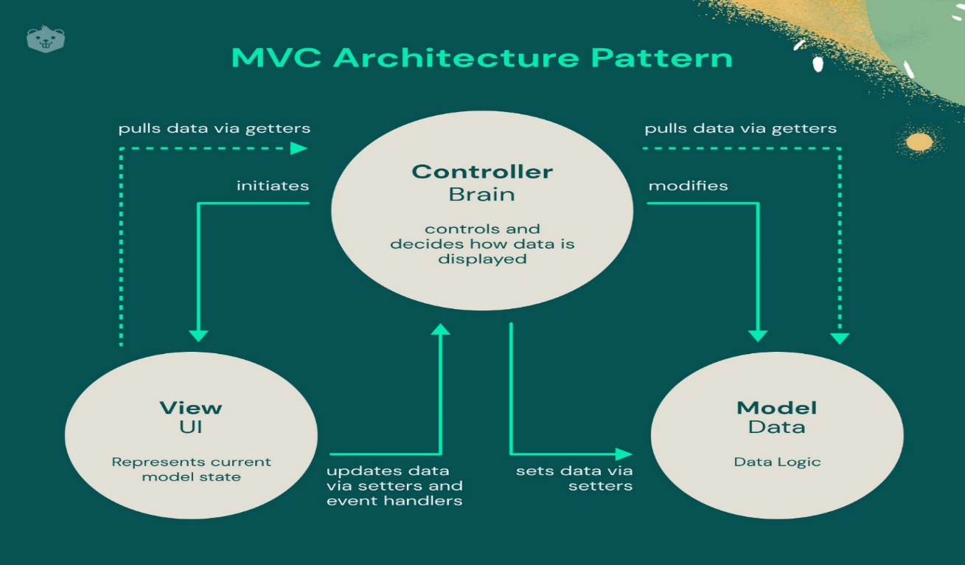
Figure 29: MVC Architecture (Source: https://encrypted-tbn0.gstatic.com /images? q=tbn:ANd9GcRx0n1oDz1SskHiZMKI5W0fAZ -KQ33yRlHruA&s )

- CLASS DIAGRAM
- Definition
The class diagram expresses the static structure of the system in terms of classes and the relationships between those classes. The interest of the class diagram is to model the entities of the information system.
- Formalism
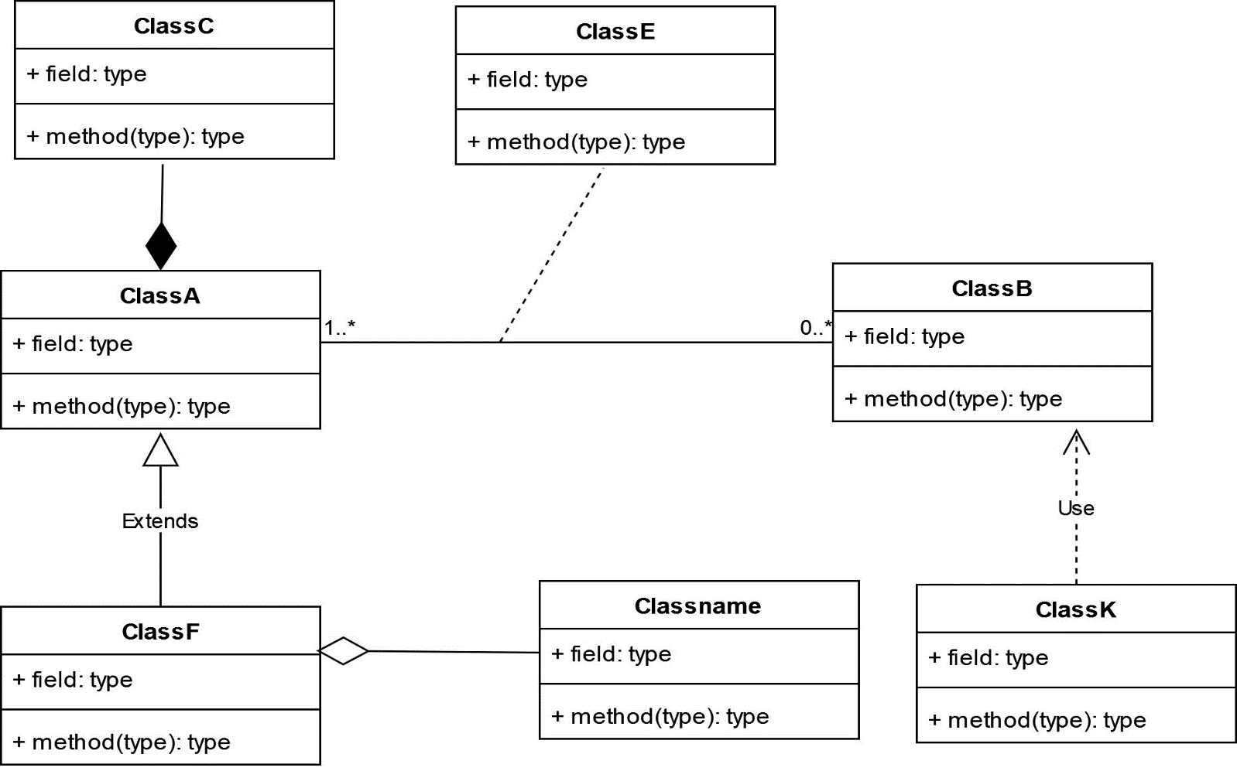

Figure 30: Class Diagram Formalism
- Components of a Class Diagram
Table 22: Components of a Class Diagram
Element | Description | Representation
class | It defines the structure, the behaviour and the relationship of these objects. | 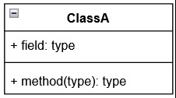
Composition | If a parent of a composite is deleted, usually, all of its parts are deleted with it. | 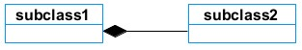
Aggregation | It models the notion that one object uses another object without "owning" it and thus is not responsible for its  creation or destruction. | 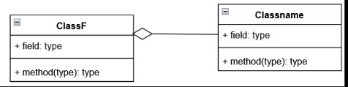
Dependency | It existed between two classes, if one changes it may cause the change in the order, but the other way around. | 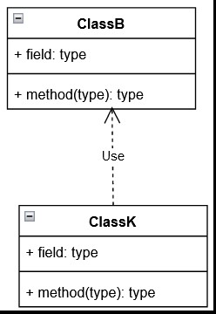
Generalization | It is a relationship between a whole thing (called superclass) and a more specific thing (called subclass) | 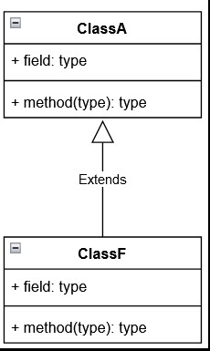
Association | It is a relationship between 2 or more classes. Types of association include Binary, Nary associations. | 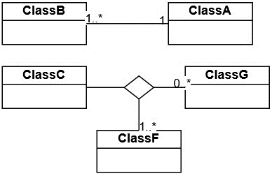
Association class | It is a class formed between 2 or more countries. | 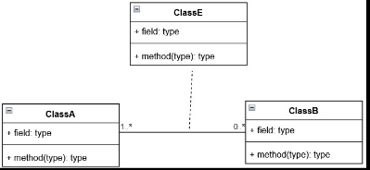

- System Class Diagram
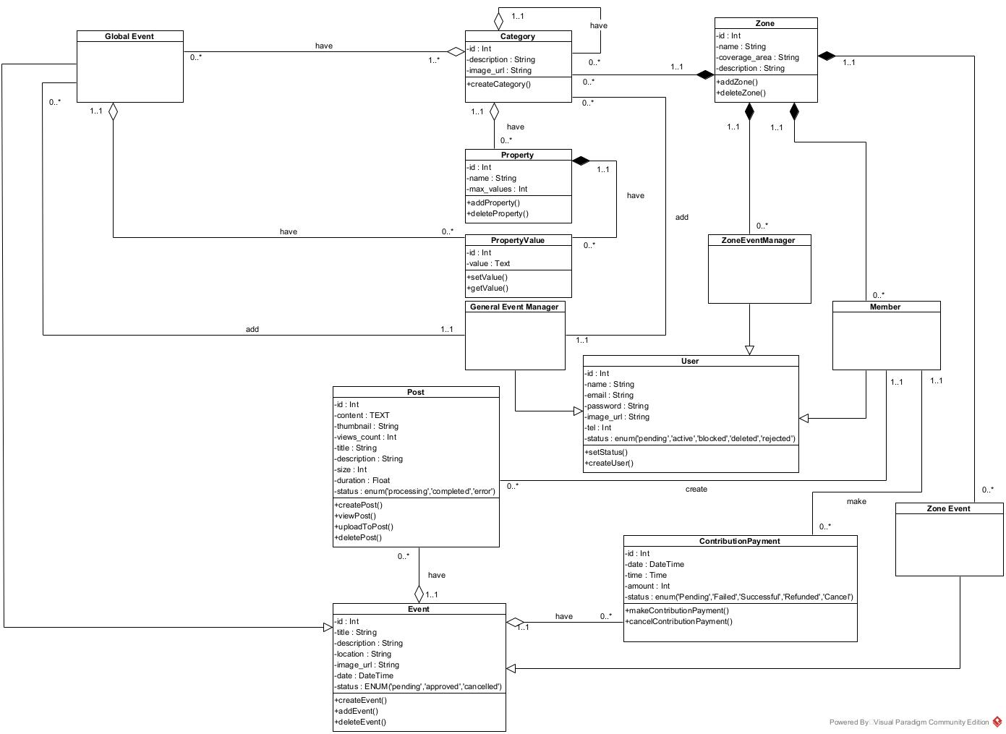

Figure 31:General System Class Diagram

- STATE MACHINE DIAGRAM
- Definition
State diagrams are used to document the various states that a class can take, and the events that cause a state transition. They are typically applied to objects, showing how they respond to events by transitioning from one state to another.
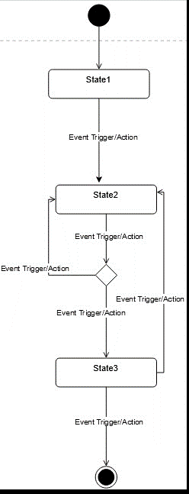
- Formalism

Figure 32: Formalism of a State machine diagram

- Components of a State Machine Diagram
Element | Description | Representation
State | Models a situation during which a certain invariant condition holds. | 
First (Initial) State | It defines the initial state | 
Final State | It represents the final state or the end of a system. | 
Transition | It is a change of control from one state to another due to the occurrence of  some events. | 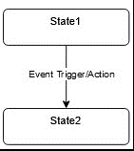
Choice pseudo State | A diamond symbol that indicates a dynamic condition with branched potential results | 
Terminate | Implies that the execution of a state by means of it context is terminated. | 
Diagram Overview | A placeholder for the linked states in a state machine diagram. | 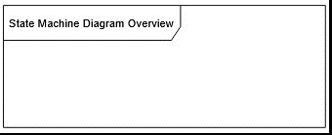
Table 23: Components of a State Diagram

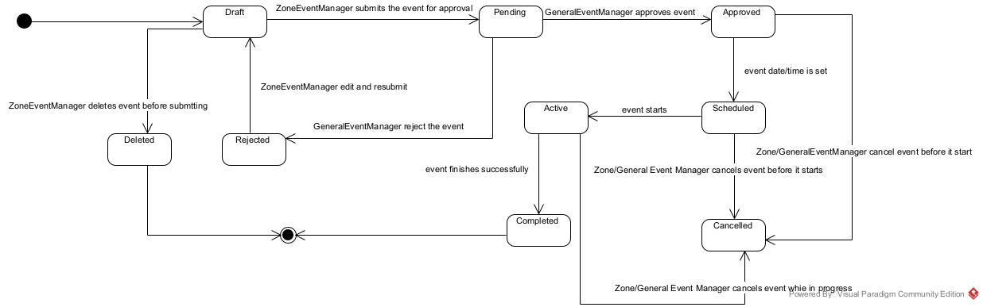
- <<Event>> State Machine Diagram

Figure 33: State machine diagram for <<Event>>

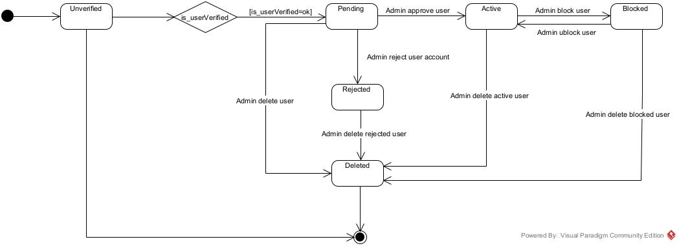
- <<User>> State Machine Diagram

Figure 34: State Machine diagram for <<User>>

- PACKAGE DIAGRAM
- Definition
Package diagram is a structural diagram used to show the organisation and arrangement of various model elements in the form of packages. They can show both structure and dependencies between sub-systems or modules, showing different views of a system.
- Formalism
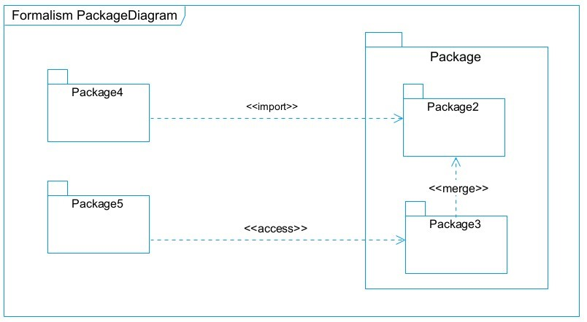

Figure 36: Formalism of a Package diagram

- Components of a Package Diagram
NAME | Description | Representation
Package | A package is used to group together logically created elements within a system. | 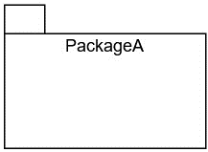
Package import | It indicates that a functionality has been imported from one packet  to another. | 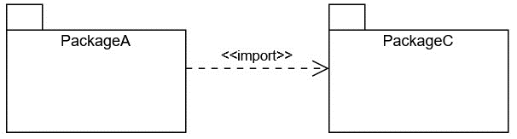
Package access | A relationship Indicates that one package requires assistance from the function of another package. | 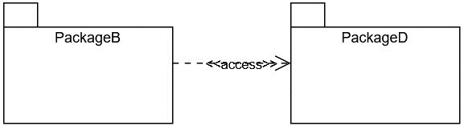
Package merge | It is a relationship which shows that, the functionality of two packages are combines to a single function. | 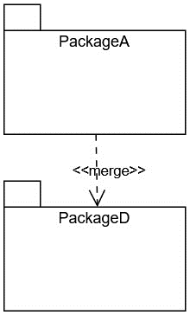
Table 24: Components of a Package Diagram

- System Package Diagram
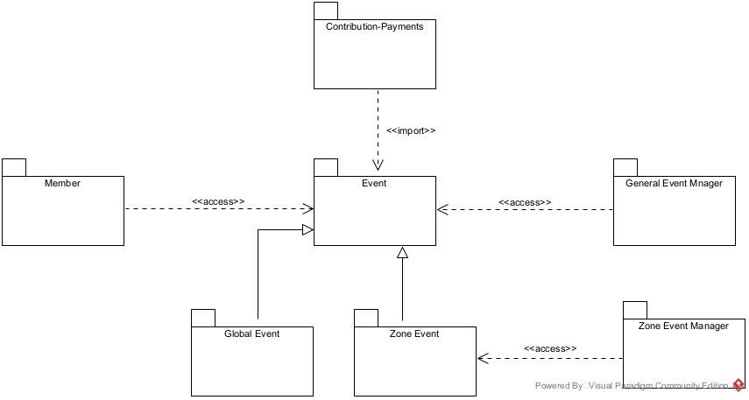

Figure 37: System Package diagram

CONCLUSION
The conception phase helped us identify the data needed to create our database and implement our application. The elements modelled in this phase gave us an overall view of the various modules of our application. Therefore, the next step in our project will be drafting the implementation or realization file, considering the elements modelled earlier.



CHAPTER 5: REALIZATION PHASE

Preamble

In the realization phase, we focus on the practical aspects of implementing the system. This includes creating the deployment diagram, which shows the physical arrangement of hardware and software, and the component diagram, which outlines the structure and relationships of the system's components. These diagrams help ensure that the system is ready for deployment and functions as intended.


II.
COMPONENT DIAGRAM

Content:
INTRODUCTION
I.
DEPLOYMENT DIAGRAM
CONCLUSION
INTRODUCTION
The realization phase is where the system design is translated into practical implementation. In this phase, we will focus on the technical details necessary to deploy the system, including the creation of key diagrams such as the deployment and component diagrams. These will help illustrate how the system's components interact and are set up in the real world.

- DEPLOYMENT DIAGRAM
- Definition
A deployment diagram is a visual representation of the physical architecture of a computer. It represents the physical disposition of material resources that constitute the system and shows the component repartition (software elements) that are executed inside these materials(nodes)
- Formalism
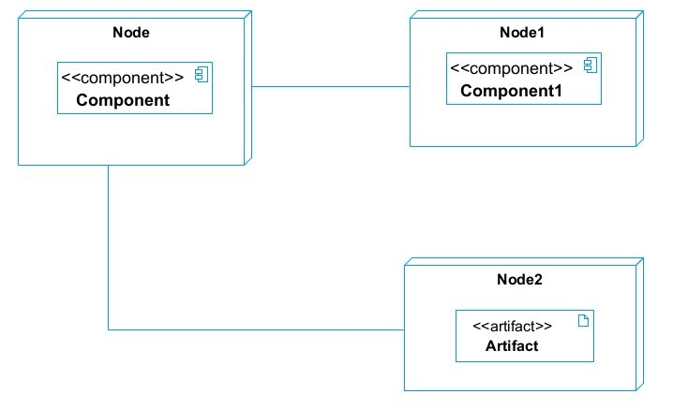

Figure 38: Formalism for Deployment Diagram

- Components of Deployment Diagram
Table 25: Components of a Deployment Diagram
Element | Description | Notation
Node | It is a hardware used to deploy the application | 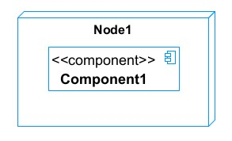
Artifact | An artefact is a major product, which is produced or used during the development of a software. E.g diagrams, data models, setup scripts | 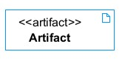
Component | It represents a modular part of a system that encapsulates its content and whose manifestation is replaceable within it environment. | 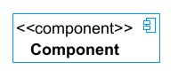
Association | An association helps to connect two nodes together which permits them to communicate  together | 

- System Deployment Diagram
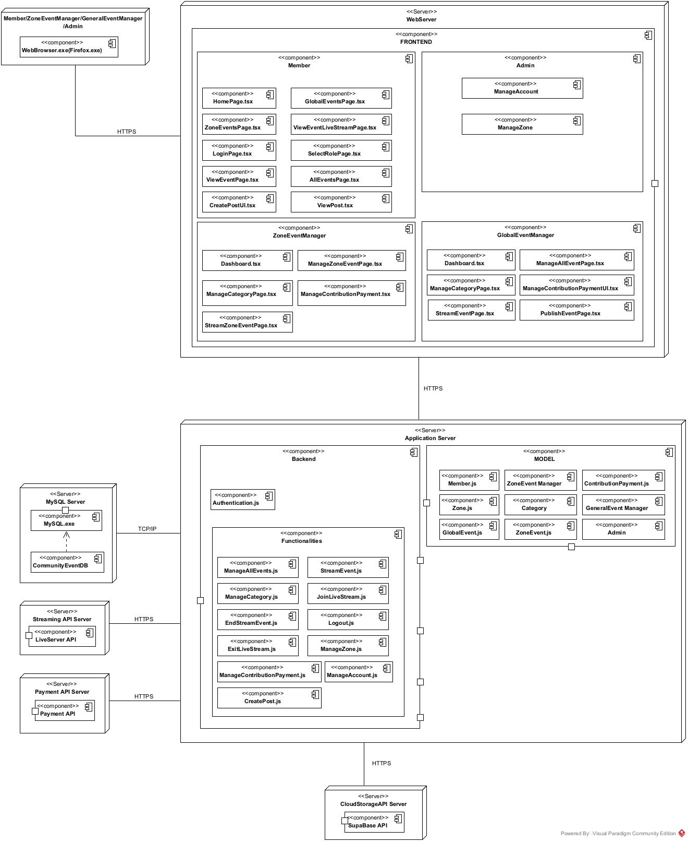

Figure 39: System's Deployment diagram

- COMPONENT DIAGRAM
- Definition
A Component diagram describes the dependencies between various software component such as the dependency between executable file and source files. They represent the internal structure of our software (Software component).
- Formalism
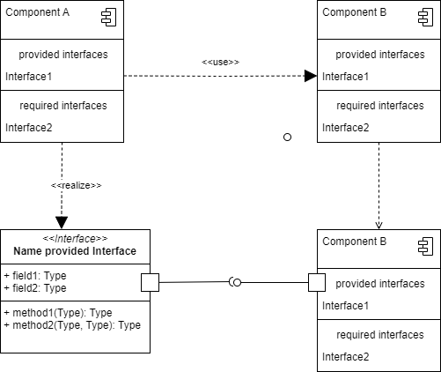

Figure 40: Formalism for Component Diagram

- Components of a Component Diagram
Table 26: Components of a Component Diagram
Elements | Description | Notation
Component | A rectangle with the component's name inside, often with two smaller rectangles on the left. It represents a modular part of a system, encapsulating specific functionality or a group of functions. | 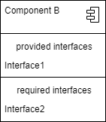
Interface | Depicted as a circle or semi-circle attached to a component, it defines a set of operations specifying the component's responsibility. | 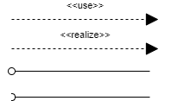
Dependency | Illustrated as a dashed arrow, it indicates that one component relies on other components to function correctly.
Port | Represented as a small square on a component's edge, it defines an entry or exit point for data or control flow.
Connector | Shown as a solid line between two components or ports, it signifies the communication path between them.

- System Component Diagram
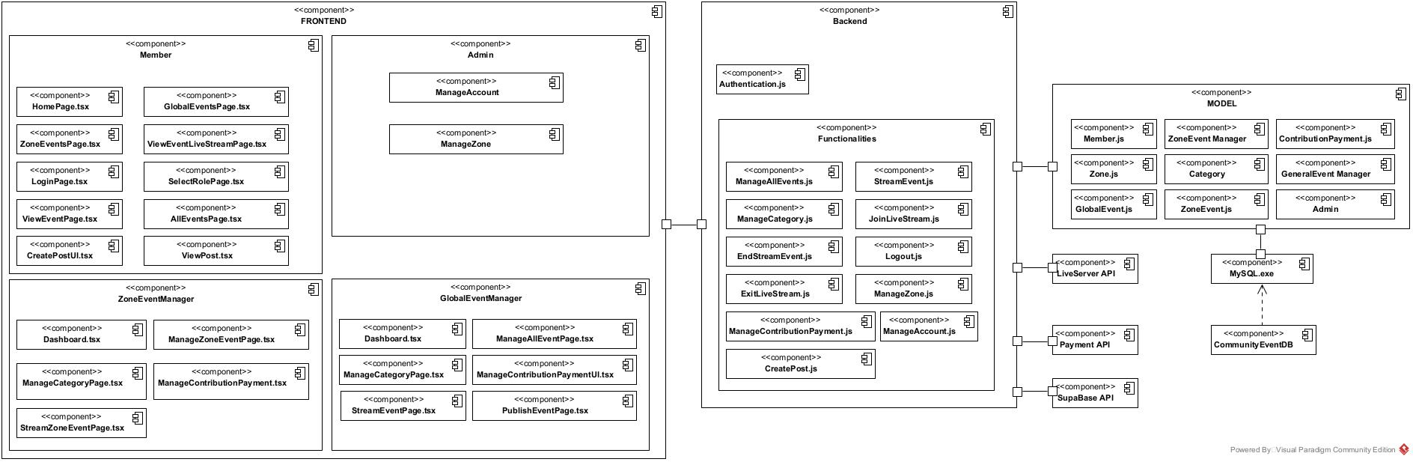

Figure 41: System's Component diagram

CONCLUSION
In this phase, we focused on both the logical and physical architecture of the application. We began with an overview of the physical architecture, which allowed us to present the system's deployment. Finally, we discussed the logical architecture, describing the various components that make up our system.



CHAPTER 6: FUNCTIONALITY TESTING

Preamble

In this section, we focus on testing our application to ensure the highest possible quality for users and to prevent potential issues from becoming bottlenecks. The goal is to verify that the software meets specified requirements and performs its expected functions.


II.
TESTS SHOWCASES

Content:
INTRODUCTION
I.
APPLICATION FUNCTIONALITIES
CONCLUSION
INTRODUCTION
Software testing is a comprehensive process that ensures that software applications are reliable, secure, and user-friendly. It encompasses a range of techniques and methodologies, each targeting different aspects of software to provide a quality product.

- APPLICATION FUNCTIONALITIES
- Event Search by Zone (Location-Based)
Community members can browse or search for events happening in their zone. Events must be linked to a specific location or community zonel.
- Event Streaming (Zone & Global)
Zone Event Managers can live stream events within their specific zone. The General Event Manager can live stream events globally. Members can view streams of events that belong either to their own zone or to the wider community.
- Event Categories
Admins and Managers can organize events into categories (e.g., cultural, social, educational) to help members easily find what interests them.
- Manage Events (Event Organizers)
Zone Event Managers and the General Event Manager can create, edit, approve, or cancel events. Zone Managers can submit events for approval, while the General Manager validates and publishes them.
- Manage Categories (Event Organizers)
Suppliers can add, edit, and delete gas bottles from the platforms.
- Fair Participation & Validation
Admins ensure events are legitimate and community-focused by validating submissions before publication.
- Account Management (Admin)
The Admin manages all accounts on the platform—community members and event managers, —ensuring smooth operations.
These features together make the PC’s TACC Community Cameroon platform a central hub for organizing, streaming, and participating in events across zones and at the global level.

- TESTS SHOWCASES
Software testing can be performed at various stages of development, such as Unit Testing, Integration Testing, System Testing, and Acceptance Testing, using different methods like Black Box or White Box testing.
In this section, we will focus on Integration Testing to ensure different components (APIs, databases) communicate and work together, and System Testing to verify the entire system, from frontend to backend, functions as a whole.
This approach ensures that both the connections between components and the overall system function as intended.

- Integration testing
- API ↔ Database Interaction
These tests ensure that the API correctly interacts with the database by performing CRUD operations. We use Postman to tests the different API end points. Below are the tests carried out on our API’s end points:
  - Event Manager Module tests
    - We tested the /api/events endpoint, which allows the frontend to display a list of all events for the General Event Manager, or zone-specific events for Zone Event Managers.
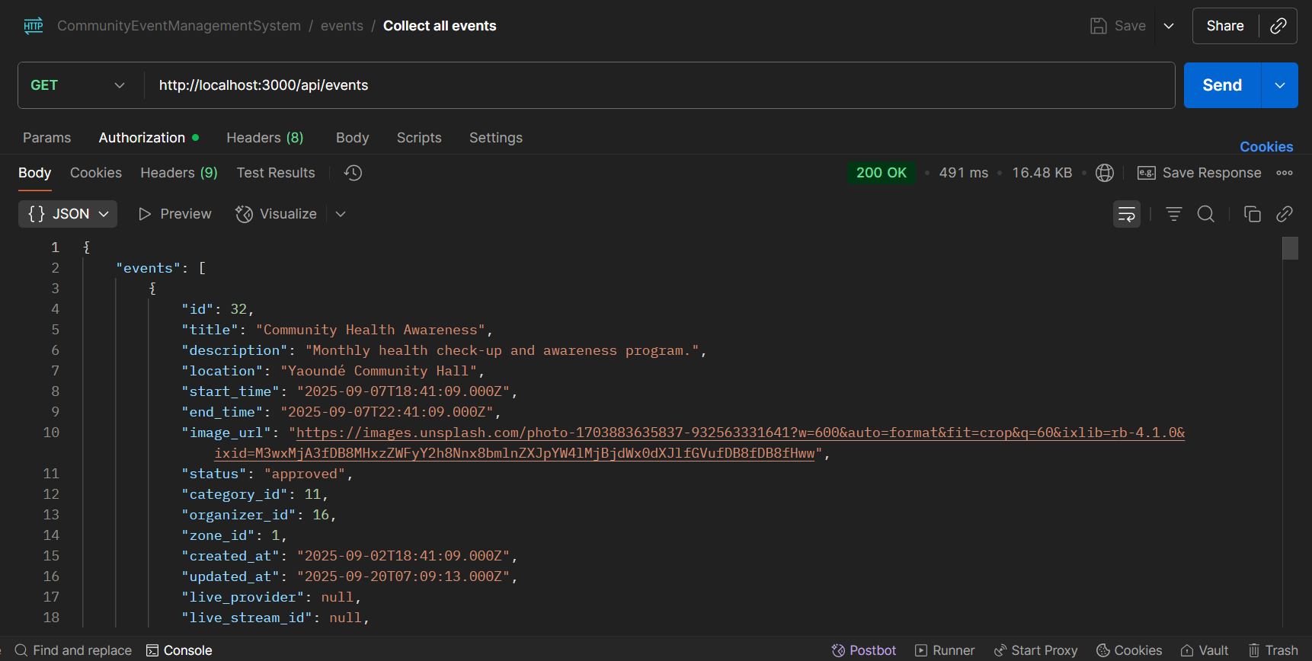

Figure 42: GET Request to /api/events to retrieve a list of zone or global events

    - We tested the /api/category parametric API endpoint, to display a list of all categories for the General Event Manager, or zone-specific categories for Zone Event Managers.
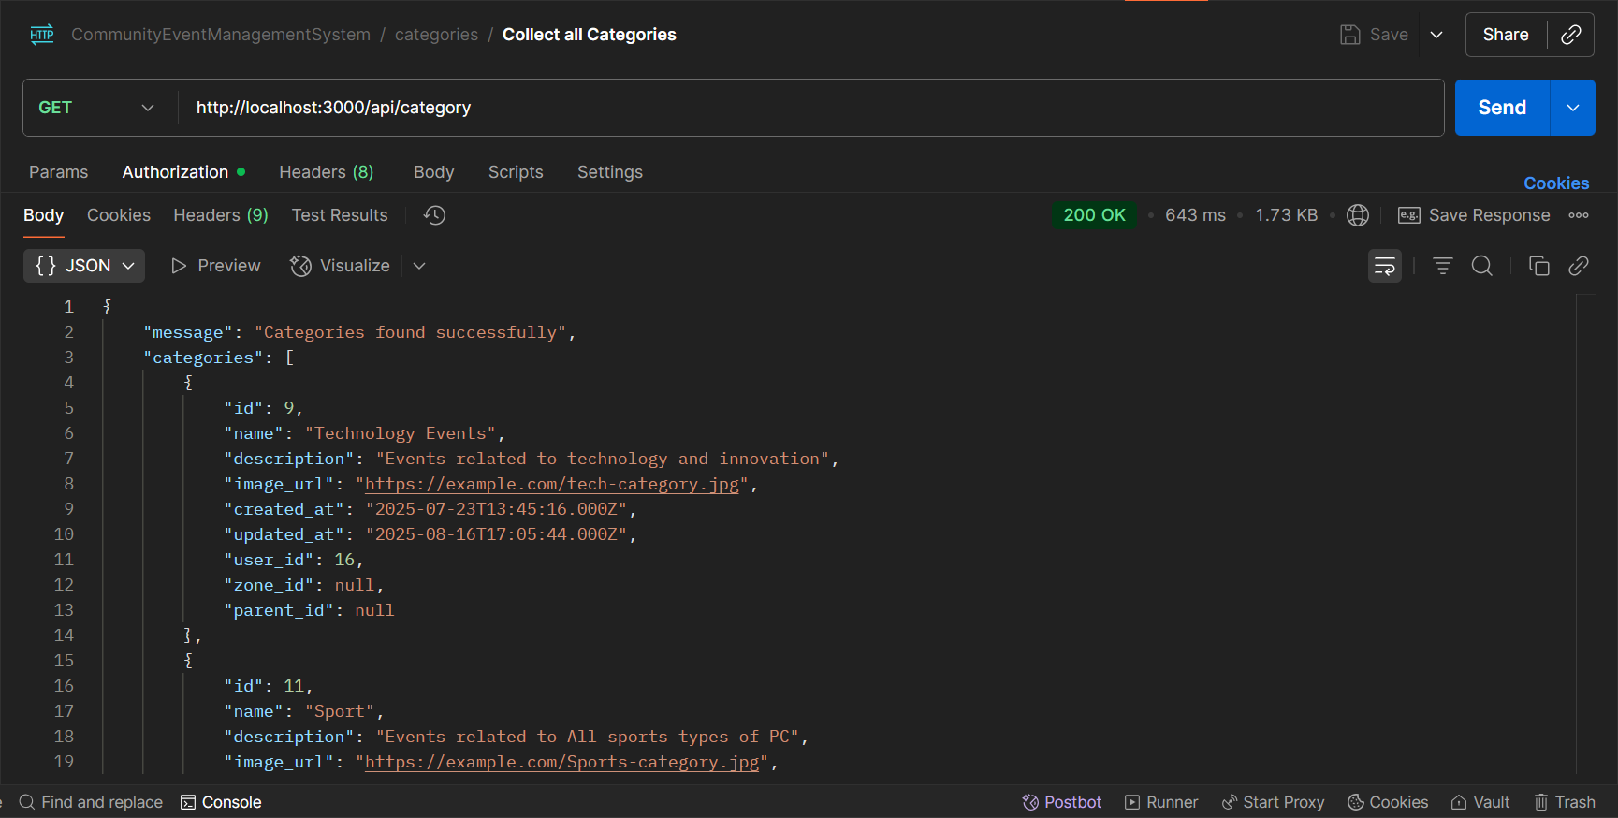

Figure 43: GET Request to /api/category to retrieve a list of zone or global category

CONCLUSION
Testing is an integral part of the software development life cycle, performed to verify the correctness, reliability, and robustness of the implemented functionality. This phase is critical in software development, as it validates the implemented features and identifies any issues for resolution.



CHAPTER 7: USER GUIDE

Preamble

A user guide explains how to use a software application in a language that a nontechnical person can understand. Thus, it enables the user to easily use the application to familiarize with the software and discover its functionalities.


III.
USER MANUAL
II.
INSTALLATION GUIDE

Content:
INTRODUCTION
I.
DESCRIPTION OF APPLICATION
CONCLUSION
INTRODUCTION
A user guide is a detailed document that offers step-by-step instructions for effectively using a product or service. It provides a wide range of information to help users understand and utilize the product efficiently. This section will provide a brief overview of our web application, followed by step-by-step instructions on how to set it up, and conclude with detailed explanations of its main features and how to use them.

- DESCRIPTION OF APPLICATION
- Purpose
PC Community Events is a web-based application designed for actors in the PC’S TACC Community Cameroon, including the General Event Manager, Zone Event Managers, and community members. The platform facilitates the creation, management, and participation in community events, supporting both physical and virtual attendance. Members can view events specific to their zone as well as community-wide events. The system addresses key challenges such as poor event visibility, manual coordination, and lack of real-time updates, while ensuring smooth communication and engagement among all actors.
- Target Audience
PC Community Events is designed for the following key actors in the PC community event management system: sector:
    - Zone Event Managers:
- Individuals responsible for creating and managing events within their assigned zones.
- Benefit: Streamlined event creation, approval, and management within their zones.

    - General Event Manager:
- The person overseeing all community events and validating events submitted by Zone Event Managers.
- Benefit: Enhanced visibility and increased sales opportunities.
    - Community Members:
- Members of the PC’S TACC community who participate in events.
- Benefits: Easy access to event information and participation in both zone-specific and community-wide events.
By addressing the needs of each group, PC Community Events aims to create an organized, accessible, and engaging platform for managing community events effectively.

- INSTALLATION GUIDE
After developing an application, there is a set of activities which must be carried out in order to make the system available for us. The step will mainly consist of hosting the web application we have on an application server and running the database on a database server. The following files will be used for the deployment.
Necessary Environment
- The database Server (MySQL)
- The application server (Apache)
- A Browser
- XAMPP SERVER INSTALLATION
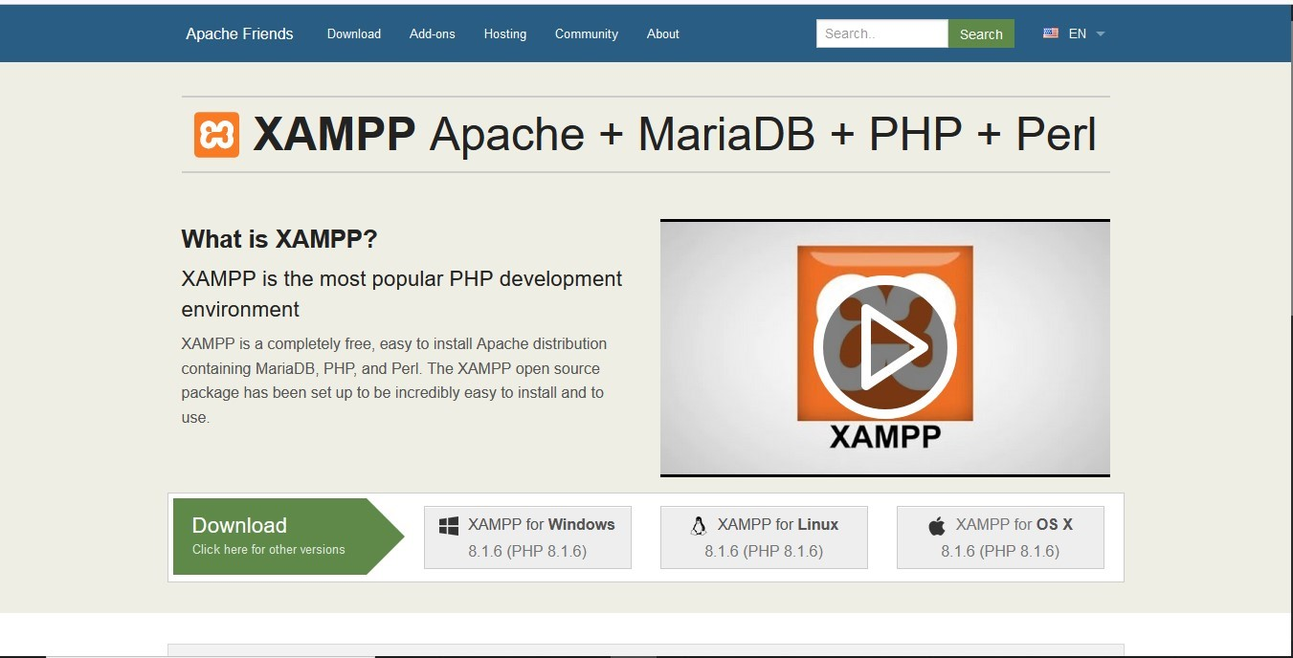
XAMPP is a free and open source cross-platform we package developed by Apache friends, consisting mainly of the Apache HTTP server; MarialDB database on a database and interpreters for scripts written in the PHP and Perl programming languages.

Figure 46: Xampp Server Installation

- download the package from the official Apache Friends webpage

- Open the Apache Friends websites.
- Click the XAMP for Windows button to save the file on your desktop.
- Make the installation package executable
- Open the terminal (Ctrl+Alt+T)
- Move into the folder where your installation package is located(By default, the system stores it in the Downloads folder.).
- Navigate to Downloads using the command:
- Cd /home/[username]/Downloads
- Make the file executable by running a _{chmod} command:
- sudo chmod 755 [package_name]
- To make the latest XAMPP installation package executable, use the command:
- sudo chmod 755 xampp-linux-x64-7.3.5.1-installer.run
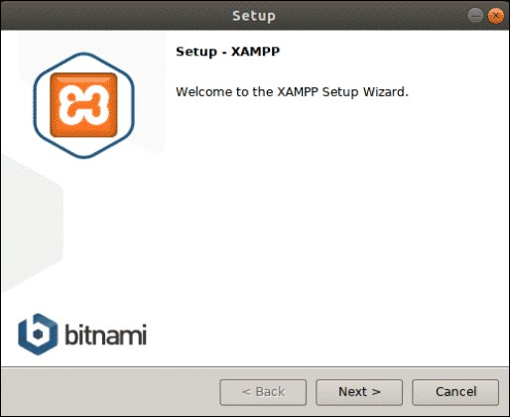
- Launch setup wizard sudo ./xampp-linux-x64-7.3.5.1-installer.run

Figure 47:Apache setup wizard welcome page

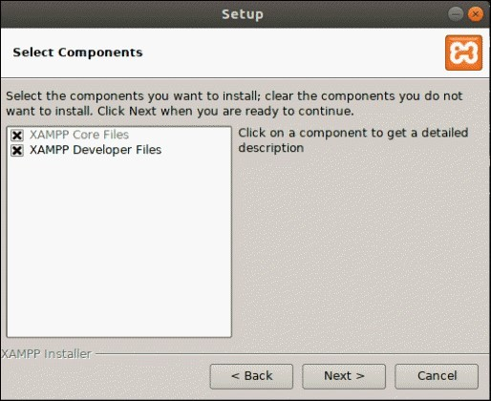
- Choose the components you want to install and click Next>

Figure 48: Apache component installation

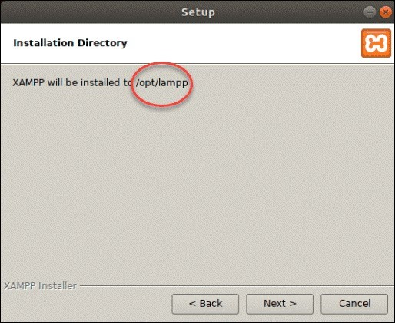
- After selecting the components, the setup wizard will show you the location where it will install the software. To proceed, click Next>

Figure 49: Installation directory selection

- The following dialogue box offers to install sponsored applications on top of the XAMPP installation. These include packages such as WordPress, Joomla, Drupal, and others. You can deny installing additional software by unchecking the Learn more about Bitnami for XAMPP box.

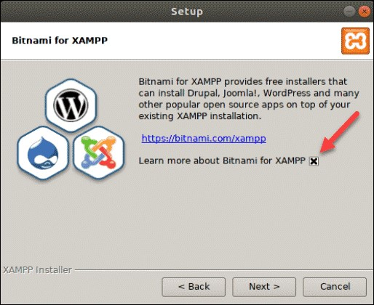

Figure 50: Installation Sponsor

- Next, the wizard will notify you that it is ready to install XAMPP on your system. Click Next to start.
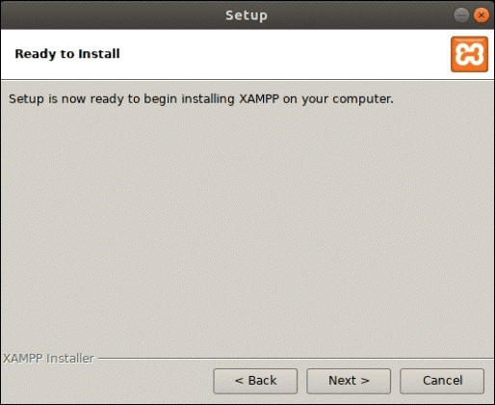

Figure 51: Ready to install

- This will launch the installation process and a dialogue box showing the progress will appear on your screen
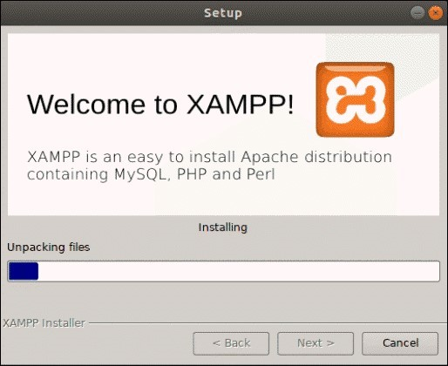
Figure 52: installation progress

- The final dialogue box should display that the setup has finished installing. You can complete the process and launch XAMPP by clicking Finish
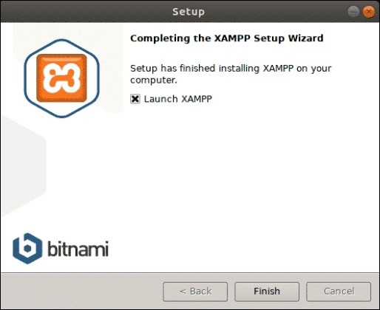

Figure 53: Installation end

- By clicking Finish in the previous step, XAMPP launches its control panel that will appear as in the image below
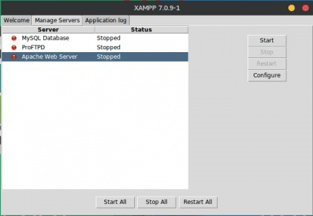

Figure 54: Installation completed
Xampp folder, extract the compressed application file in the the htdocs folder found in the xampp folder. After this, your application can be accessed on the browser via the localhost, and we get the default index page of our application.
- USER MANUAL
In this part, the steps of carrying out the operations will be explained in detail. All this will be done through tests and explanations with screenshots in support to allow users not only to know how to actually do manipulations, but also to allow them to have an overview of the results they should expect.
- Connecting to the platform
Connecting to the platform is not complicated at all. However, it is essential to meet a number of prerequisites, namely:
- Have a terminal (computer, tablet or smartphone);
- Have installed a web browser (preferably the most recent version) in your terminal;
- Enter the URL : http://localhost/
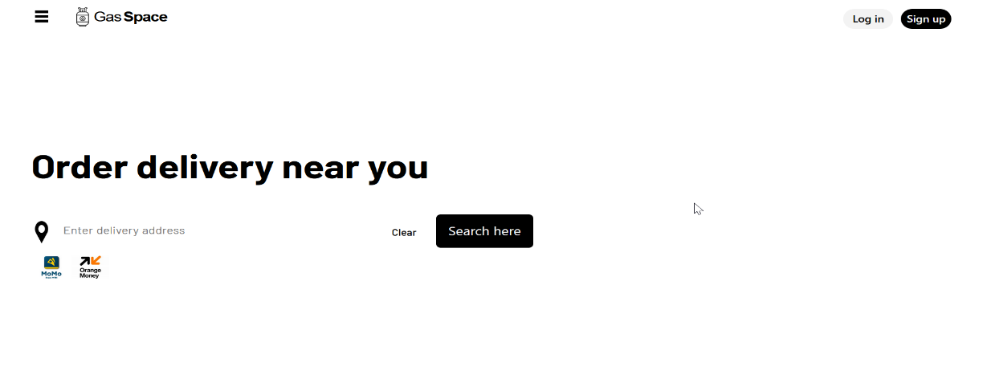
You will then obtain this page

Figure 55: Welcome page

- Here we have User (Member) Dashboard
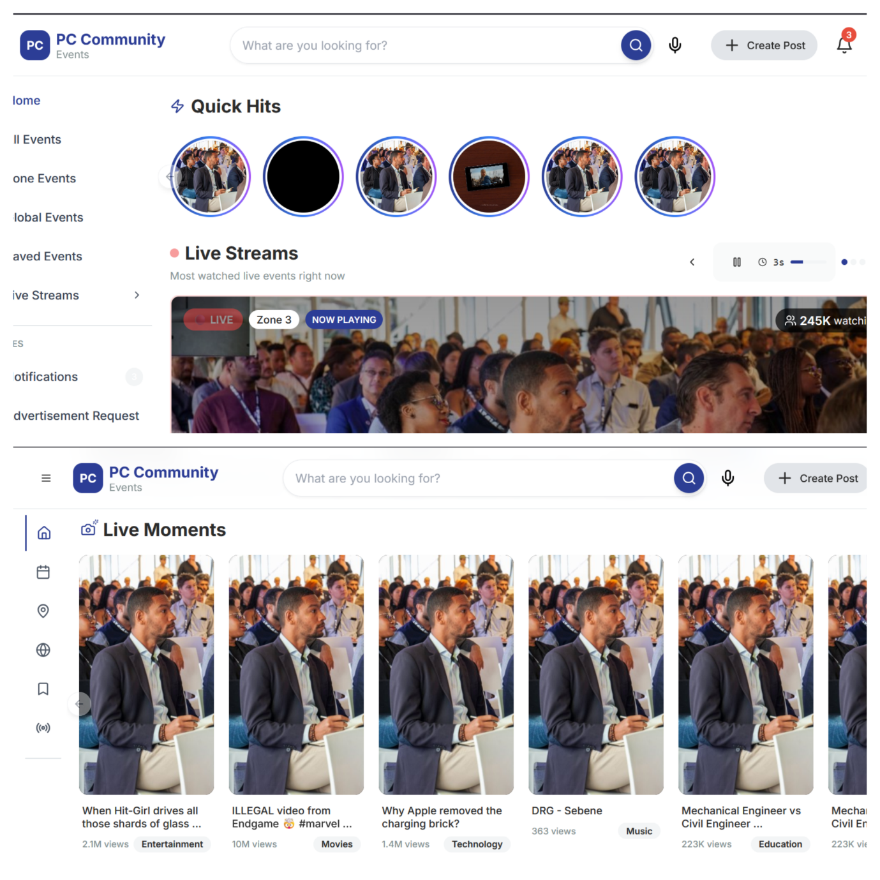
Figure 56: User (Member) Dashboard page

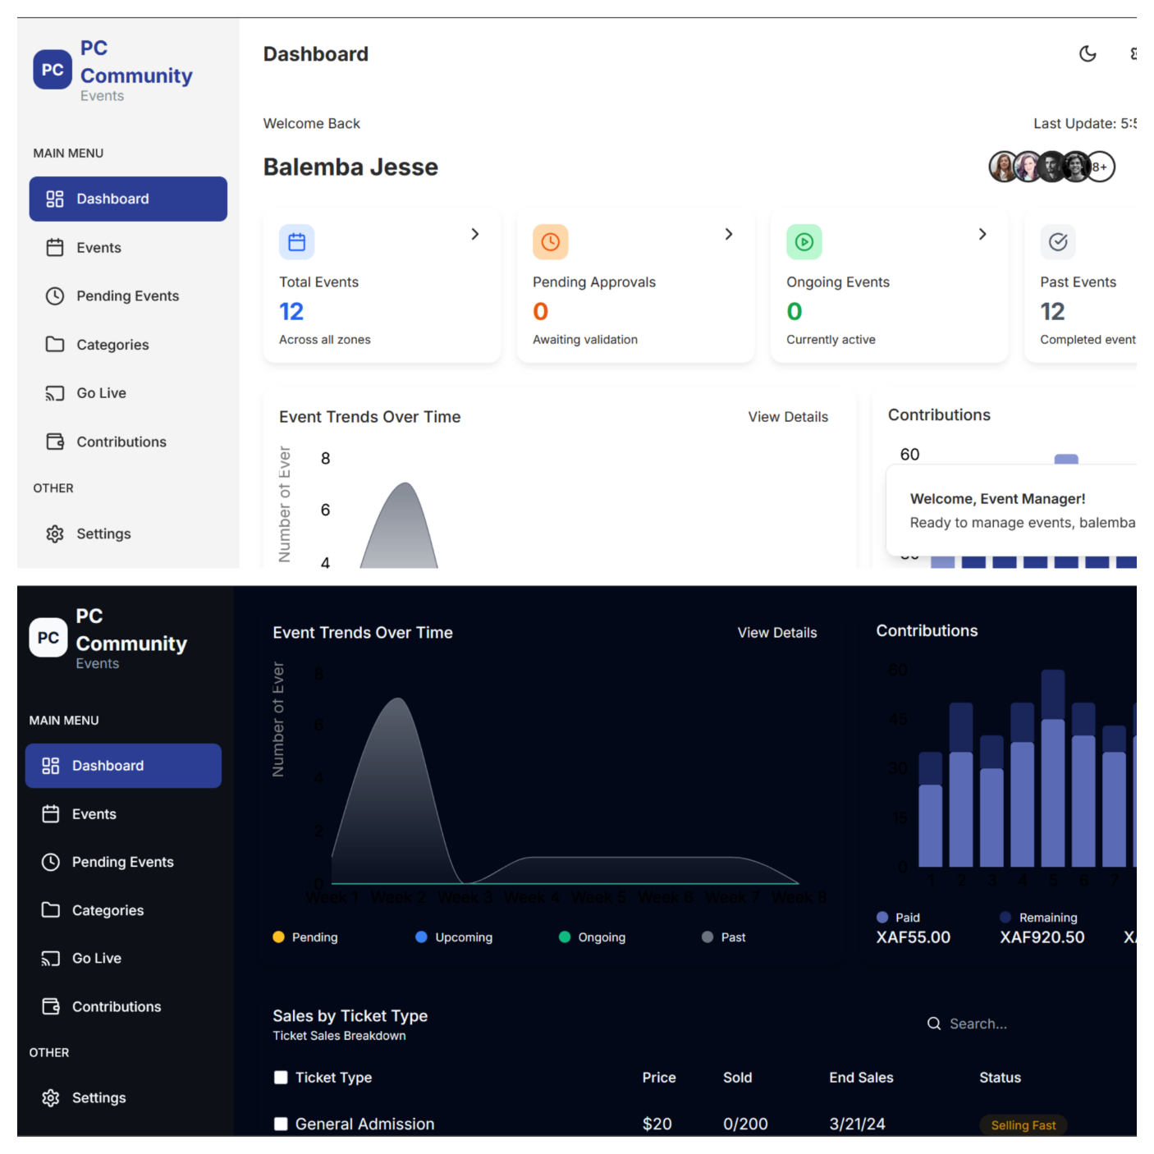
- General Event Manager Dashboard

Figure 57: General Event Manager dashboard

CONCLUSION
As we conclude this final phase of the report, we have outlined the procedure for deploying the application. The main interfaces have also been presented to help users become familiar with the platform's functionalities and appearance, ensuring a smooth onboarding experience.

GENERAL CONCLUSION

In conclusion, this project has examined the event management practices within the PC’S TACC Community in Cameroon and identified major challenges such as limited communication channels, poor visibility of events, manual scheduling errors, and lack of real-time updates. To address these issues, we developed a web-based event management system designed to streamline event creation, approval, and participation. The platform enhances transparency, efficiency, and accessibility by enabling zone-based and community-wide event management, real-time notifications, and event streaming. By implementing this solution, we aim to strengthen communication, boost participation, and modernize how community events are organized and experienced, ultimately fostering greater unity and engagement within the PC’S TACC Community.

ANNEX

BIBLIOGRAPHY

- UML 2 For Dummies 1st Edition 2003 by James A. Schardt and Michael Jesse Chonoles.
- GanntProject Introduction for Beginners. 65 pages;
- Mercurial 2024 – 2025;
- Javascript_tutorial by tutorialspoint. 50 pages.

WEBOGRAPHY

- https://nextjs.org/docs/app/getting-started/project-structure | Next js App Router to Structure and Organization
- https://www.w3schools.com/js/default.asp | JavaScript Tutorial
- https://developer.mozilla.org/en-US/docs/Web/JavaScript/Reference/Global_Objects Standard built-in objects
- https://developer.mozilla.org/en-US/docs/Web/API/Event/target | Event: target property

TABLE OF CONTENTS

